Cruzr S2 RobotVersion V0.3.0) Basic Use,Configuration and Task Operation Guide V1.0 （Self-developedCharging Pile)
Table of Contents
1.【Unpacking Steps】 2
2.【Power On】 2
3.【Power Off】 2
4.【Configure WiFi】 2
5.【Computer Connects to the Robot Hotspot】 3
6.【UDoke Interface】 3
7.【Mapping - web】 3
8.【Inserting Points into the Map】 3
10.【Testing Point-to-Point Navigation on the Map Interface】 5
11.【System Status】 7
12.【Configure the Map and Charging Pile Task】 21
13.【Battery Level Announcement】 22
14.【Emergency Button】 22
15.【Replacing the End Effector】 22
16.【Mode Switching】 23
17.【Configure the Box-Handling Task】 ----- Rail Navigation 24
18.【Configure the Box-Handling Task】 ----- Free Navigation 28
19.【Configure Folder Permissions】 29
20.【Mounting Files】 ----- Box-Handling Task Files 29
21.【Mounting Files】 ----- Charging Pile Task Files 30
22.【Configure Box Size and Rack Height】 31
23.【Fine-Tuning the Robot Gripper Position】 32
24.【Image of the Robot Recognizing the Box Dividing Line】 34
25.【Installing the Wrist Camera Wiring Harness of the Two-Finger Gripper】 35
26.【Localization Loss in Large Venues and Solutions】 42

【Note】Before re-flashing the robot (secondary development version, etc.), save the relevant calibration files to the computer to prevent accidental deletion!!!
Connect the computer to the robot via Ethernet cable or the robot hotspot
ssh walker@192.168.11.3 (password: aa) ssh walker@192.168.11.3 (password: aa). At the same time, do not delete any folders under /etc/walker on the robot at 192.168.11.2 and 192.168.11.3 to prevent accidental deletion.
The following are the calibration files of the Cruzr S2 camera, LiDAR, kinematics, and hand-eye calibration. Do not delete them under any circumstances!!!!
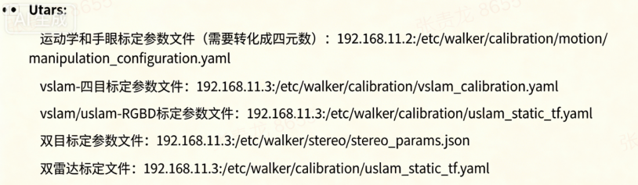

1.【Unpacking Steps】
The robot is inside the flight case. Power on the battery at the bottom of the robot (green). After a moment, the wheel-hub brake unlocks, and the robot can be pushed. Note: the robot's two-arm clamping plates must not touch the chassis shell (which may cause scratches or paint peeling); do not start the robot inside the flight case (do not enable motion control inside the flight case!!!).
Note: Ifthe robot has been powered off for more than 3 hours, the battery enters sleep mode. When powering on again, plug in the original charger to charge and activate the battery.
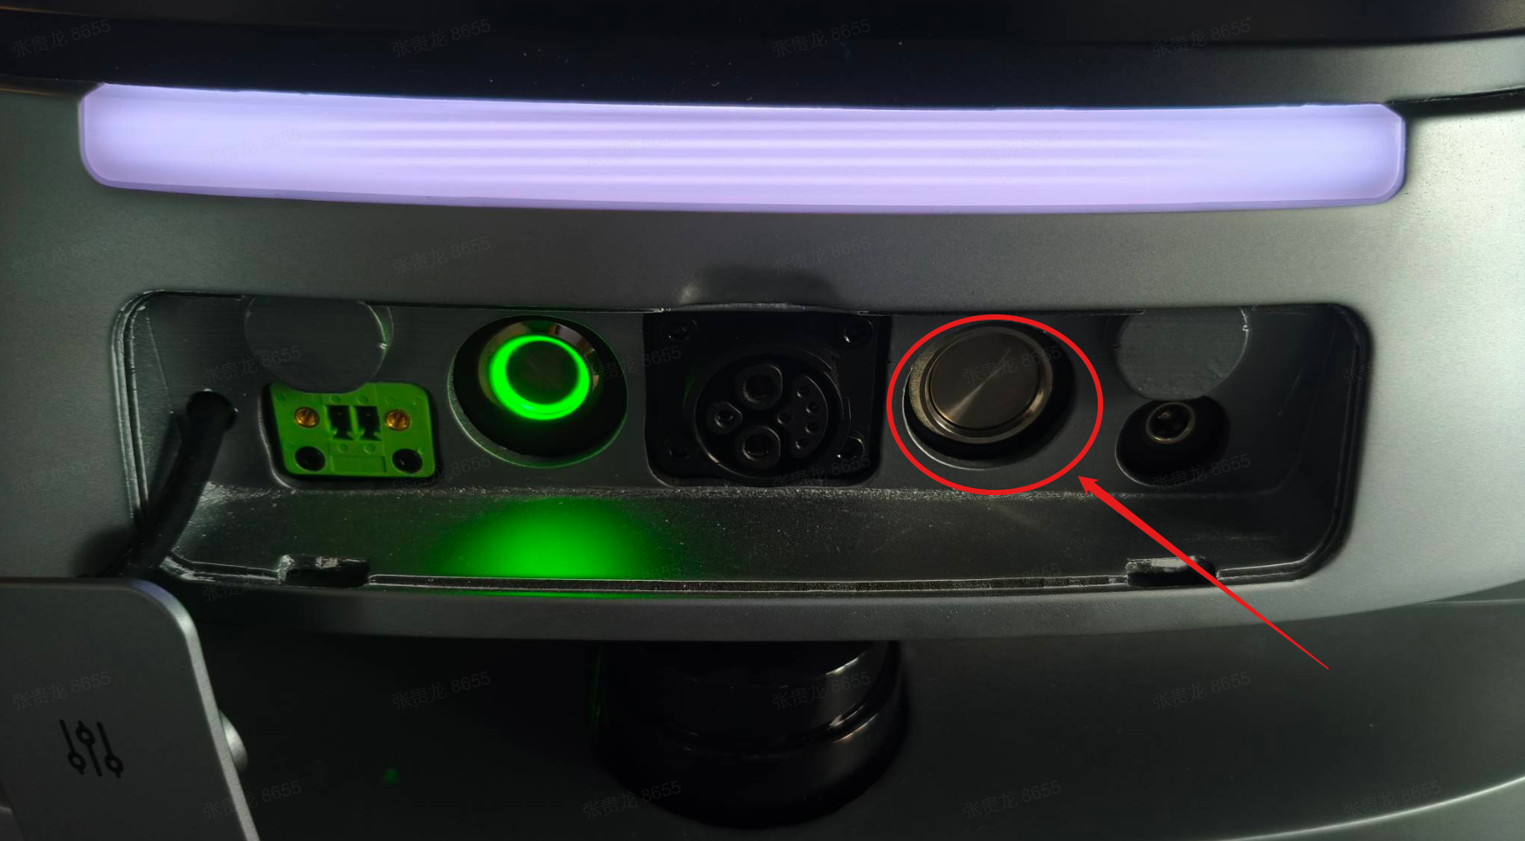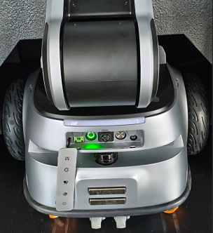
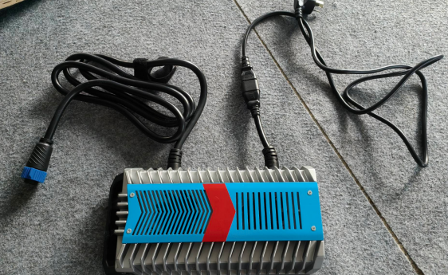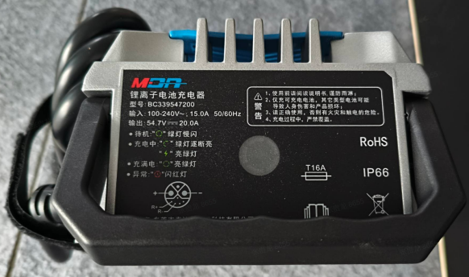

2.【Power On】
Plug in the charger to activate the battery, and make sure the emergency button is in the released state
Press the power switch at the bottom (green), press the white hard switch on the right shoulder, press and hold the soft switch for 8s, then release; the robot then enters the power-on process
1. (V0.3.0) Map and charging pile configured: after power-on, the robot announces: Charging pile service is starting, self-checking, self-check passed, motion control enabled, setting map, localization succeeded, then the robot navigates by itself to the charge0 point to stand by. (Prerequisite: the map has been set up and the charge0 point has been placed on the map about 1.2 m in front of the charging pile.)
2. (V0.3.0) Map and charging pile not configured: after power-on, the robot announces: self-checking, self-check passed, motion control enabled.

3.【Power Off】
Standard method: first briefly press the soft switch, then press and hold it for 15 seconds and release. The robot announces the battery level, then announces: I am about to shut down. The mainboard powers off (the fan stops spinning). Then press the white hard switch, and finally press the power switch at the bottom (the light turns off).
Non-standard method: directly press the white button on the right shoulder to cut power to the mainboard, then press the power switch at the bottom (the light turns off).
There is a chassis wheel-hub motor switch on the right side of the chassis that must be turned on; otherwise, after the robot enables motion control, the remote control cannot make the robot move or rotate.
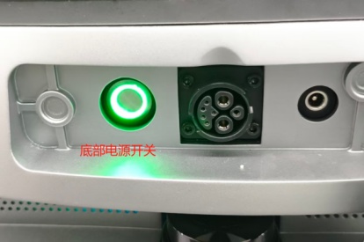

4.【Configure WiFi】
Enter 192.168.11.3 in the browser (Account: UBTNB Password: ILOVEUBT)
System Settings -- Network & IP Service -- Change, and switch to a WiFi that can connect to the network in the current environment, so that the robot connects to the WiFi of the current environment.
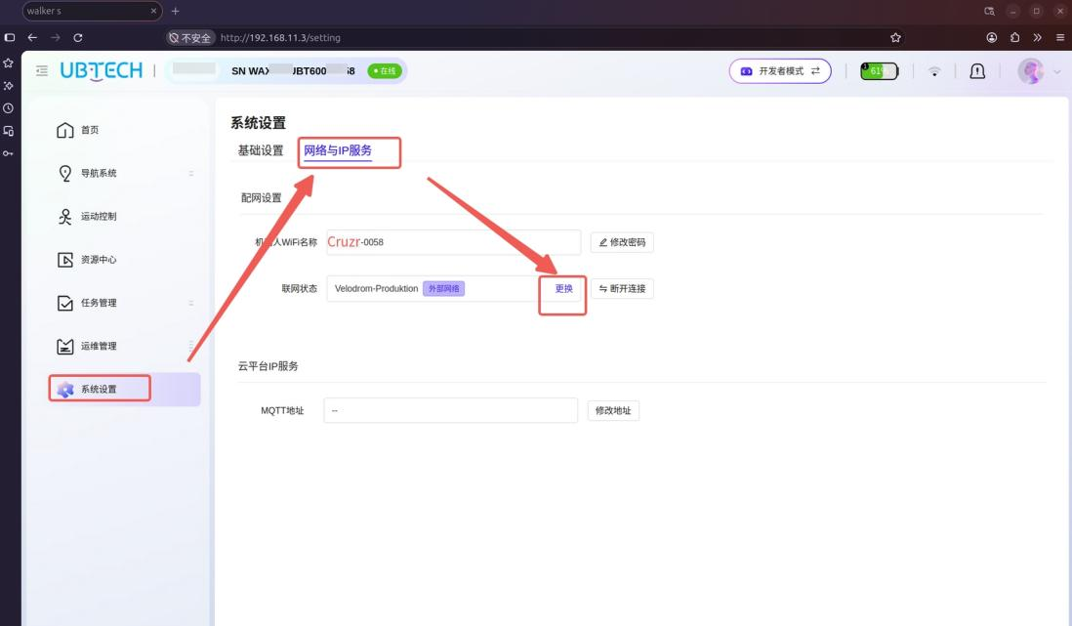

5.【Computer Connects to the Robot Hotspot】
The hotspot name emitted by the robot itself is Cruzr S2-XXXX, and the password is Ubtrobot-XXXX (XXXX represents the last four digits of the robot SN). For example: hotspot name Cruzr S2-6204, password Ubtrobot-6204.

6.【UDoke Interface】
Robot backendweb page http://192.168.11.2:9000 Account: walker Password: Walkerubtnb666
The computer needs to connect to the robot via Ethernet cable (change the computer IP to 192.168.11.99, gateway: 255.255.255.0) or connect to the robot hotspot. First, connect the computer to the robot's WiFi hotspot: hotspot name Cruzr S2-6204, password Ubtrobot-6204. For different robot SNs, the hotspot name and password follow the same format (6024 is the last 4 digits of the robot SN).

7.【Mapping - web】
After opening the webbackend page http://192.168.11.3 (Account: UBTNB Password: ILOVEUBT), go to 【Navigation System】-【MapManagement】, then start 【Mapping】. Enter a map name, then scan the map. Use the remote control to move the robot clockwise or counterclockwise to clearly scan the boundary of the current environment; try to keep people out. If the map is large and has ring structures, map slowly and rotate slowly at corners. After returning to the starting position, travel a distance along the same path to complete loop closure of the map. You can see the map refresh and complete the loop, then save the map.
Note: place the charging pile near a corner in advance. There must be no obstacles within 3 m in front of the charging pile, and scan the charging pile completely into the map.

8.【Inserting Points into the Map】
After opening the webbackend page http://192.168.11.3 (Account: UBTNB Password: ILOVEUBT), go to 【Navigation System】-【MapManagement】, select the map just created, use and edit it, then insert a point. The robot head rotates left and right to visually recognize the current environment, then localizes. At this time, the robot arrow icon can be seen on the map, indicating that the robot has successfully localized at its position on the map. Then, 1.2 to 1.5 m in front of the center of the charging pile, with the robot facing away from the charging pile, 【Insert Point】 and name it charge0, then save the map.

【Map Path】 ssh walker@192.168.11.3 (password: aa) Location: /etc/walker/map/test123. The map name can be changed. Open the test123/umap/umap.json file in the configured map folder to see the detailed point information; the point names can also be changed.


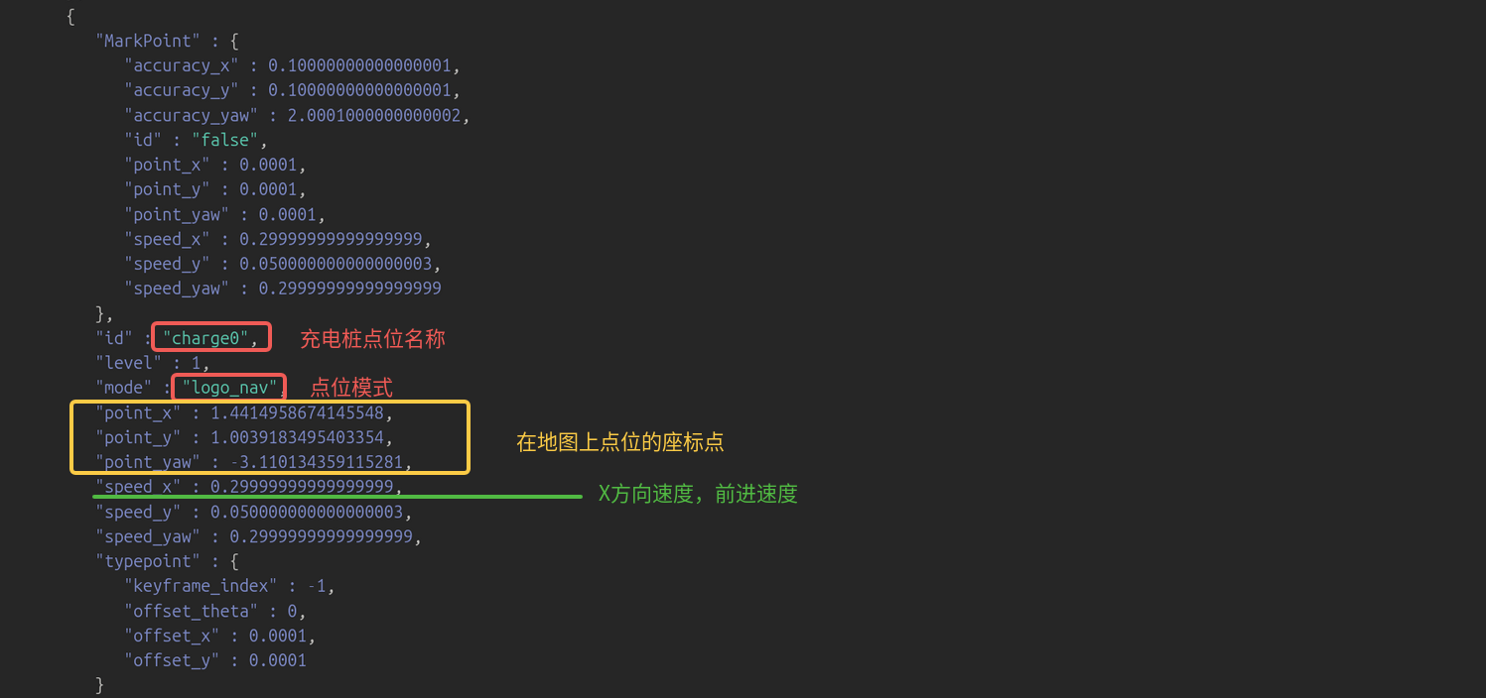

- 【Modify the Robot Navigation Speed and Turning Speed】
ssh walker@192.168.11.3 (password: aa) /etc/walker/map/test123/umap/umap.json
Change the speed_x of get1, 2, put1, 2 to 0.99 (maximum 1 m/s), and the turning speed speed_yaw to 0.79 (maximum 0.8). This means the navigation speed to reach the get1 point is 0.99 m/s, and the turning speed at the point is 0.8 rad/s.
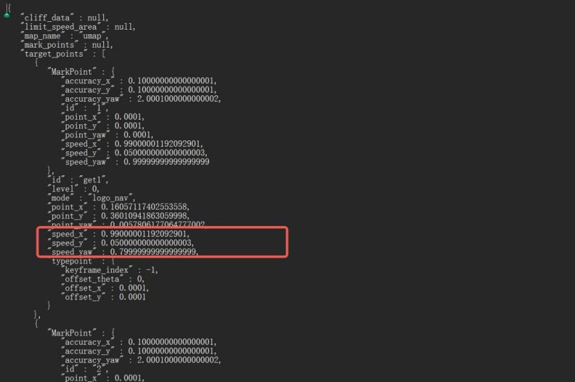

10.【Testing Point-to-Point Navigation on the Map Interface】
After opening the web backend page http://192.168.11.3 (Account: UBTNB Password: ILOVEUBT), go to 【Navigation System】-【Map Management】-【Use Map】(the newly created map test123), set it up successfully and perform re-localization, then you can jump to the formal map navigation page. Then go to 【Navigation System】-【Map Navigation】and click a point, and the robot will automatically navigate to that point.

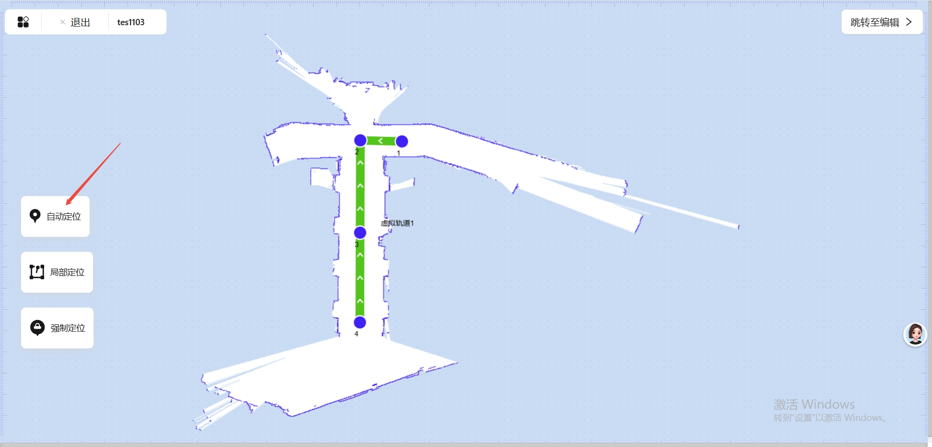
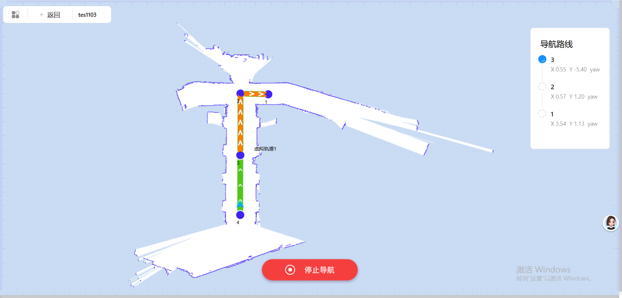
Robot re-localization:
【Automatic Localization】: the robot automatically localizes its current position globally in the map.
【Local Localization】: click the approximate current position of the robot in the map; after clicking the localization button, the robot will re-localize at a position within 2 m around the clicked position.
【Forced Localization】: click the current position of the robot in the map; after clicking the localization button, force the robot to re-localize at the clicked position.
【Jump to Edit】: if you want to edit elements in the map, click this button and the page jumps to the editor page of this map.

11.【System Status】
After opening the web backend page http://192.168.11.3 (Account: UBTNB Password: ILOVEUBT), the robot has the capability to report its status. On the web page, you can view multi-dimensional important data such as the robot's real-time status, temperature, and warnings. Association-group users perform experimental tests, and R&D testers troubleshoot robot-related issues. The abnormal statuses include the following:
（1）Robot joints
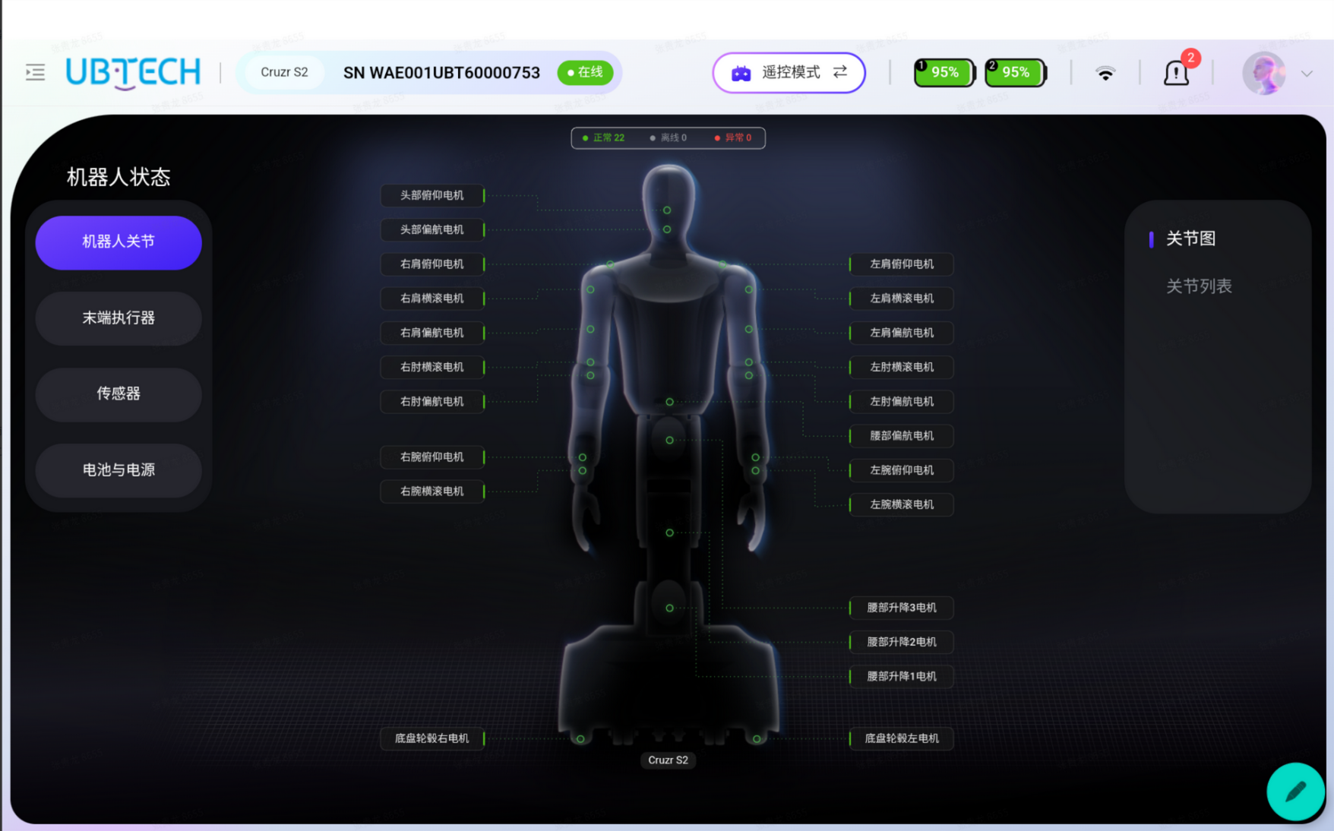
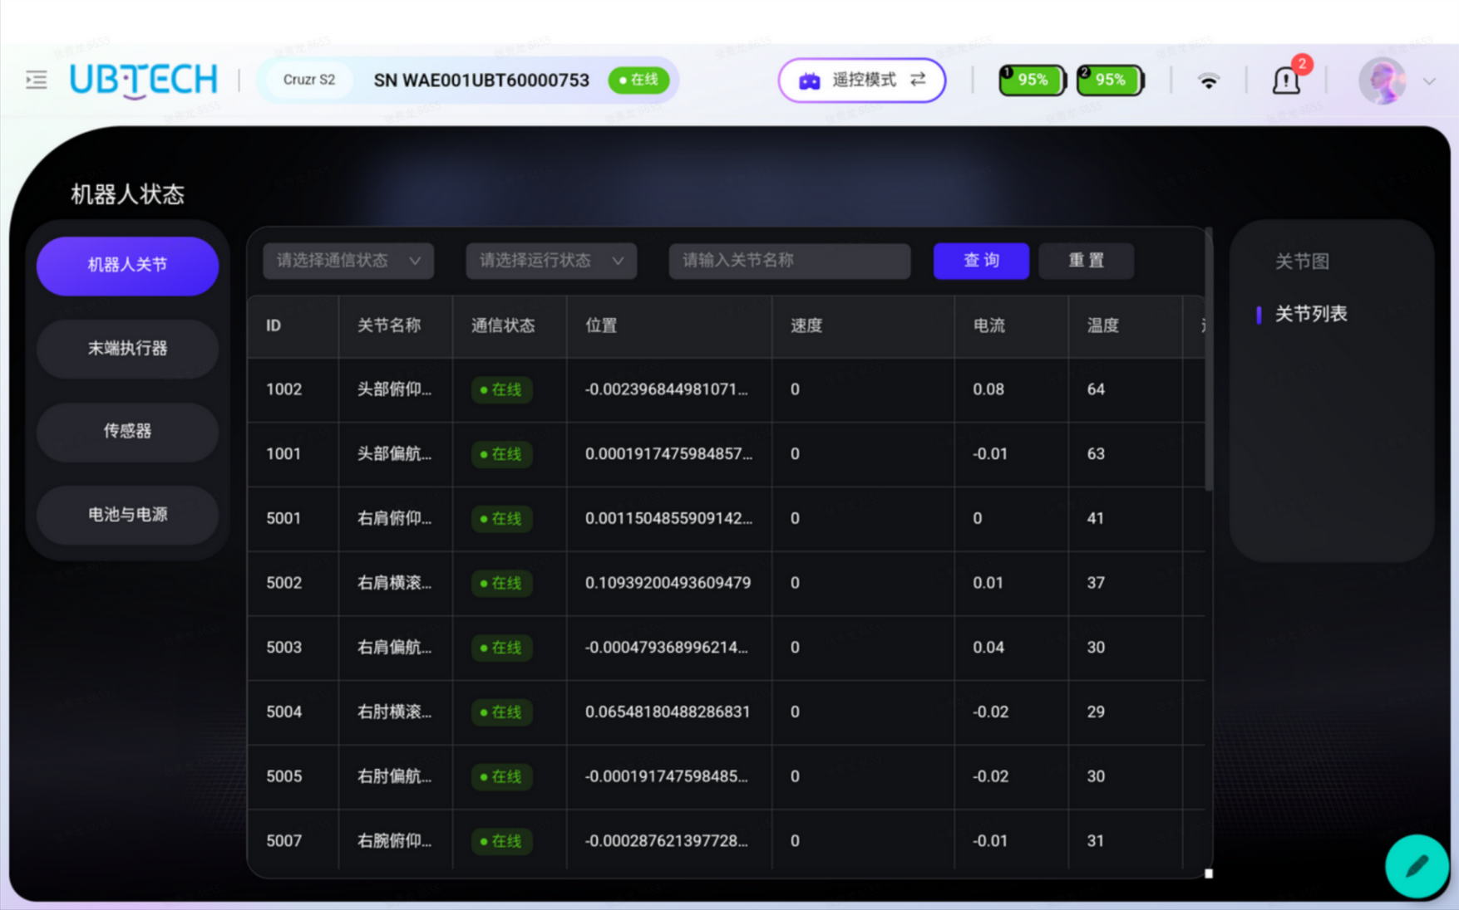
Robot joints: displays data related to each joint, such as online status, motion status (normal/fault), temperature, position, velocity, and current.
（2）End effector
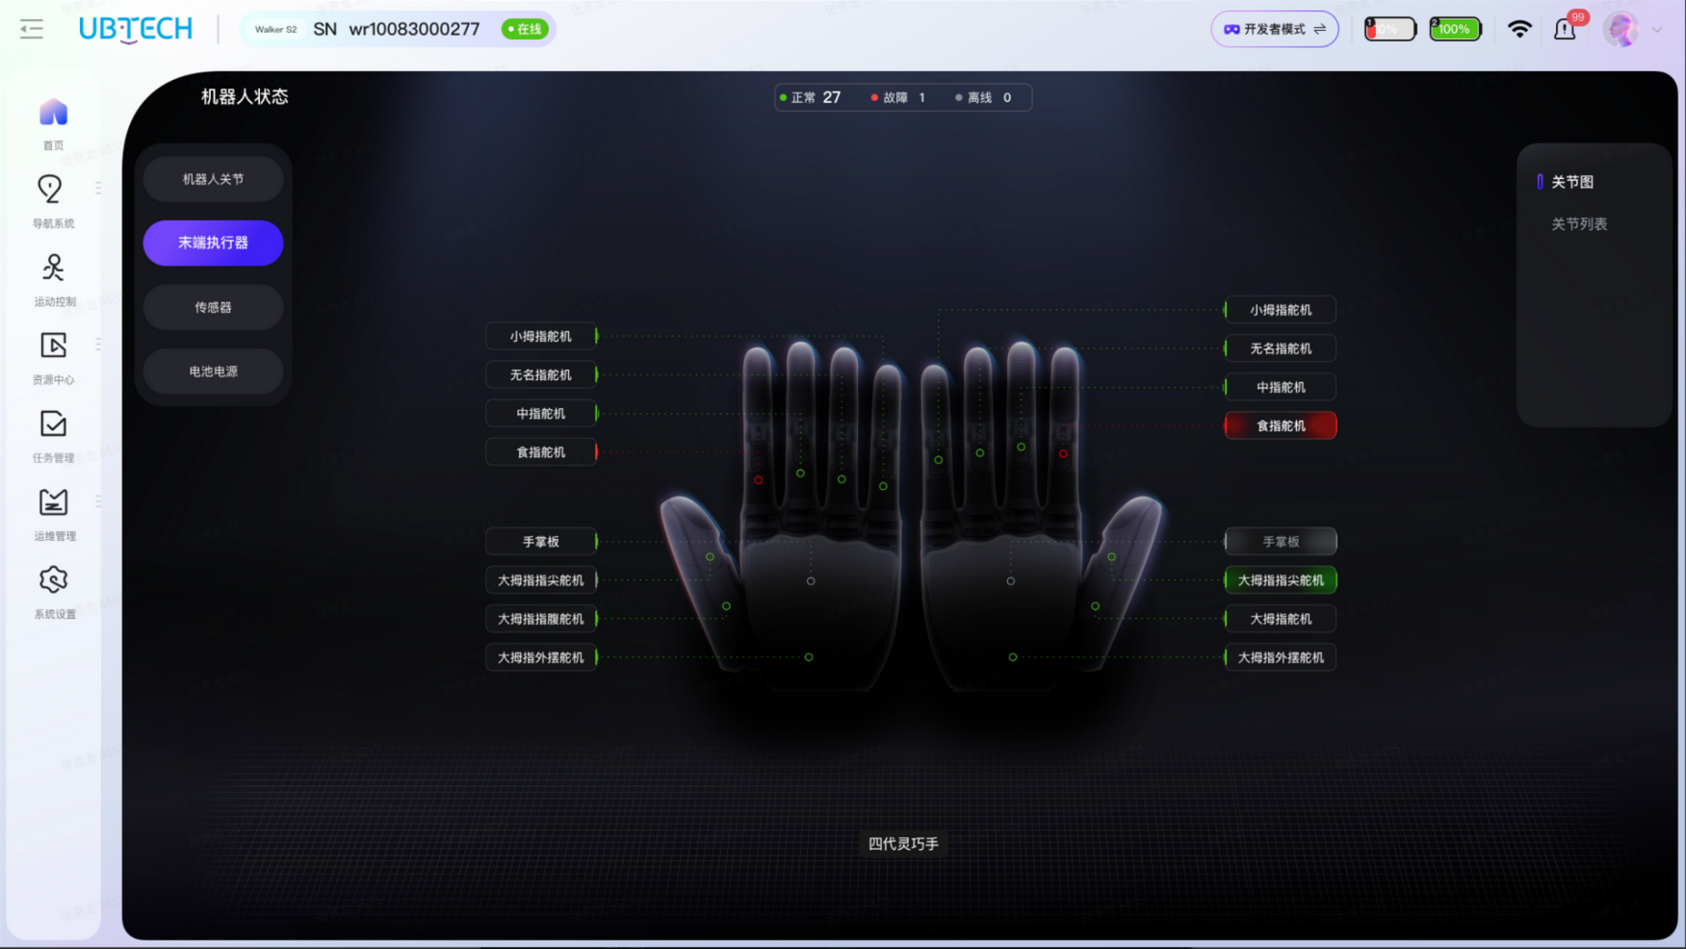
End effector: obtains the motor data of the end effector, such as servo status, etc.
（3）Sensors
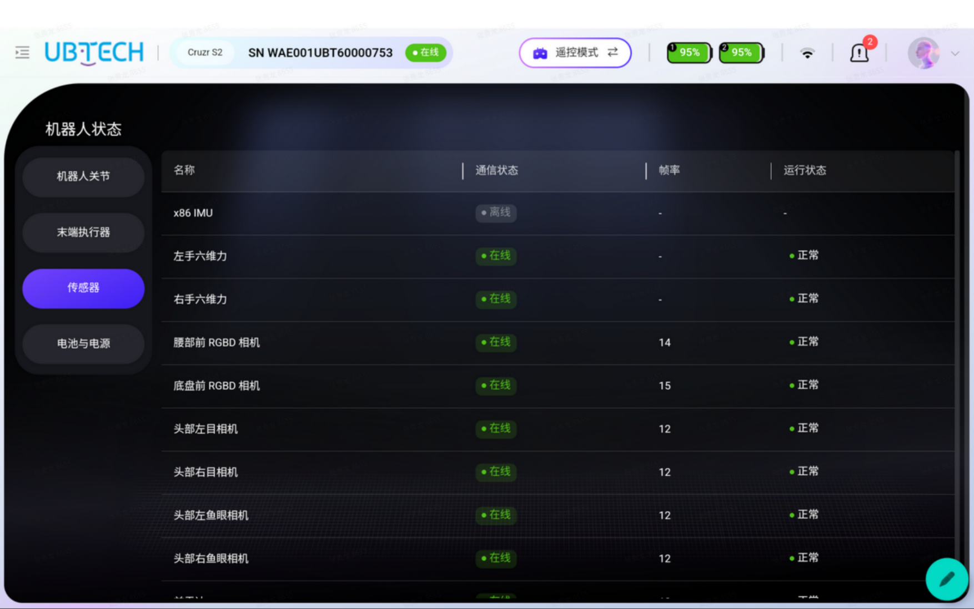
Sensors: data related to the IMU, vision sensors, and six-axis force sensors, such as online status and operating status.
（4）Battery and power
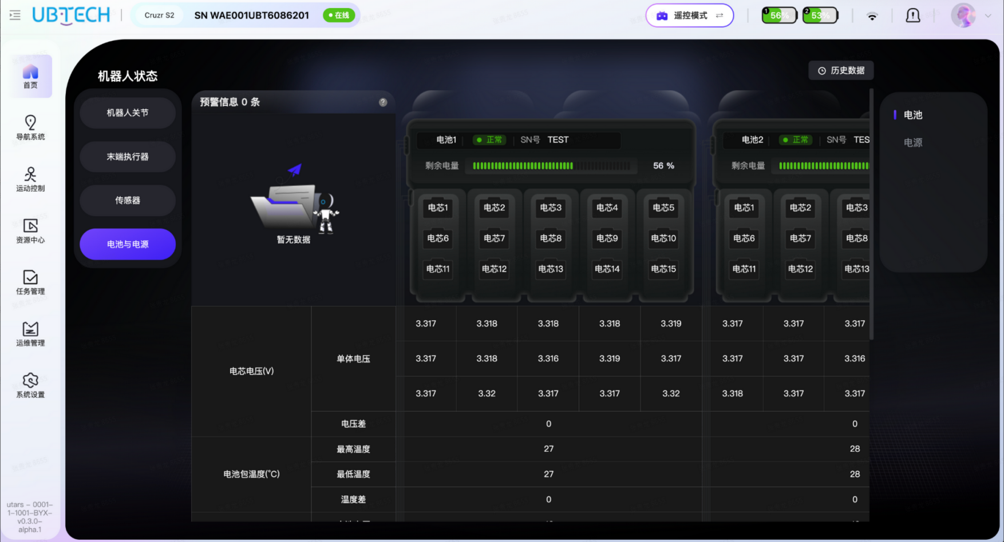
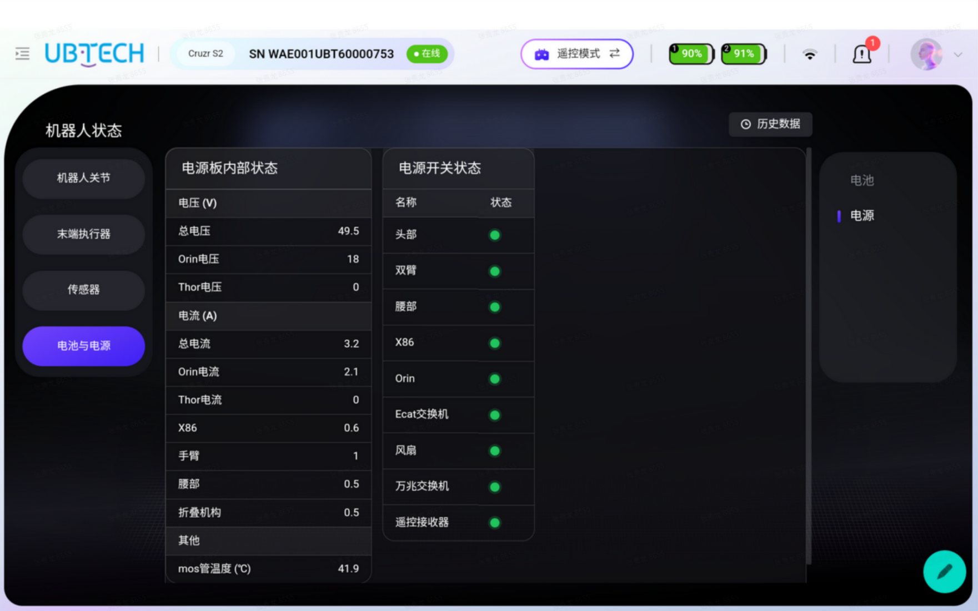
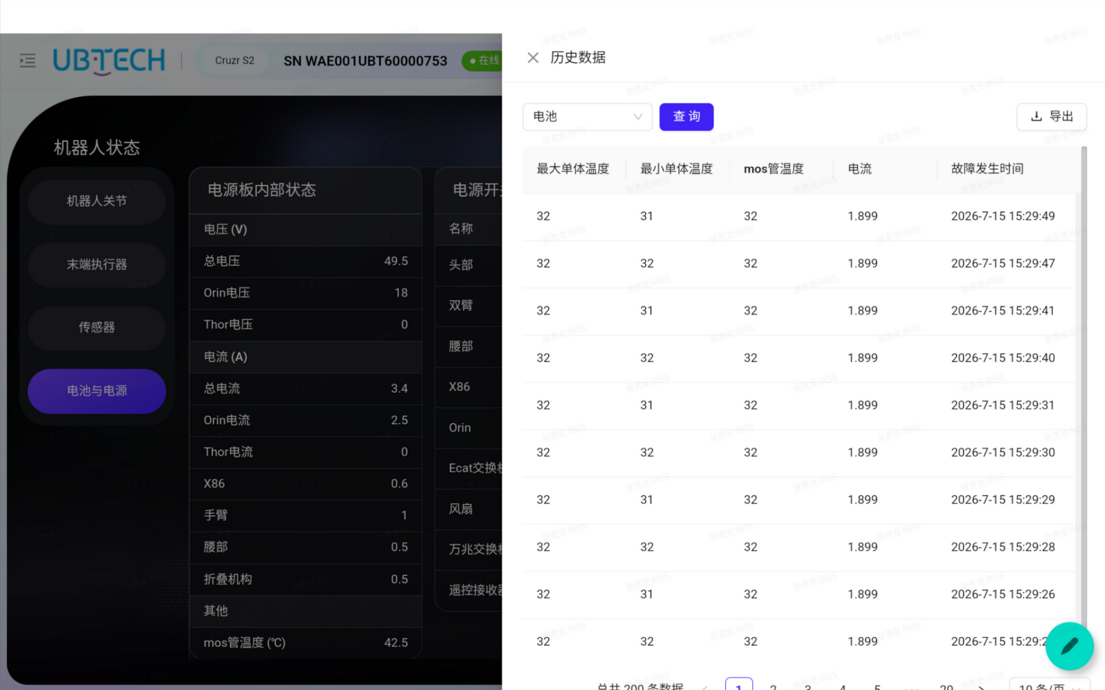
Battery: battery-related data, such as charge level, voltage, current, and temperature.
Power: power board data such as voltage, current, and temperature; parallel power board data; joint switch query.
History data: you can query all robot data, such as battery history data and power board history data, and data export is supported.
（5）Resource center
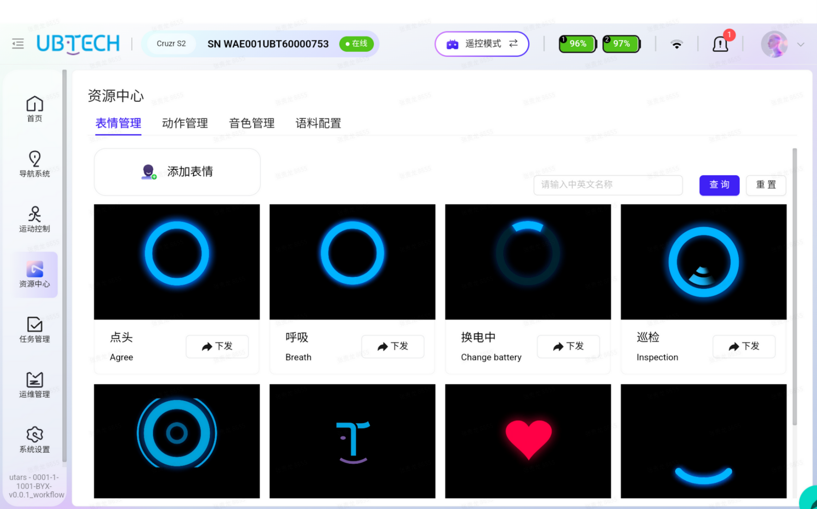
【Expression Management】: issue an official expression and the robot face displays it;
【Motion Management】: after issuing the official motion library, the robot executes the issued motions;
【Voice Management】: if available, the robot system voice can be set;
【Corpus Configuration】: if available, upload or configure the robot's corpus Q&A;
（6）Industrial tasks
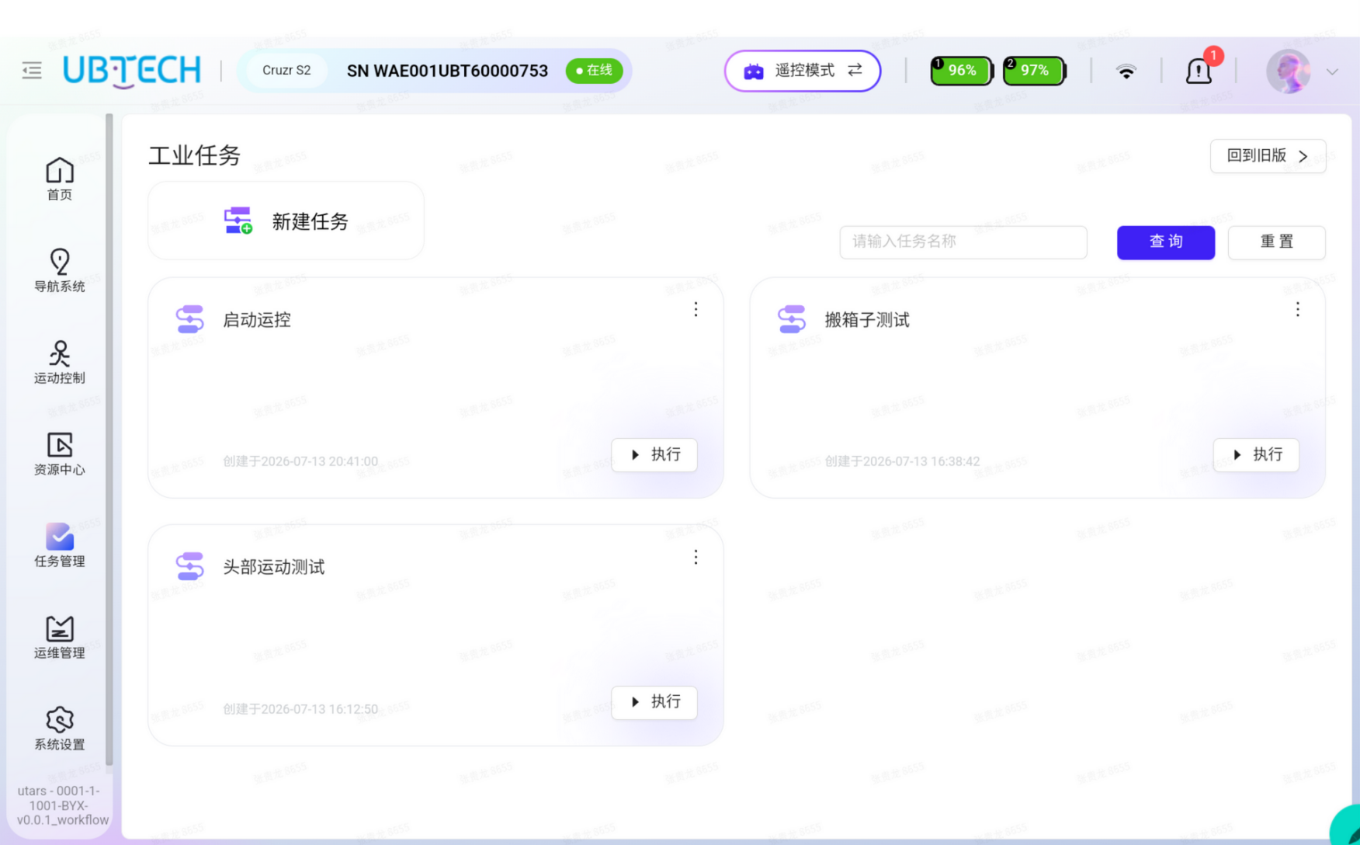
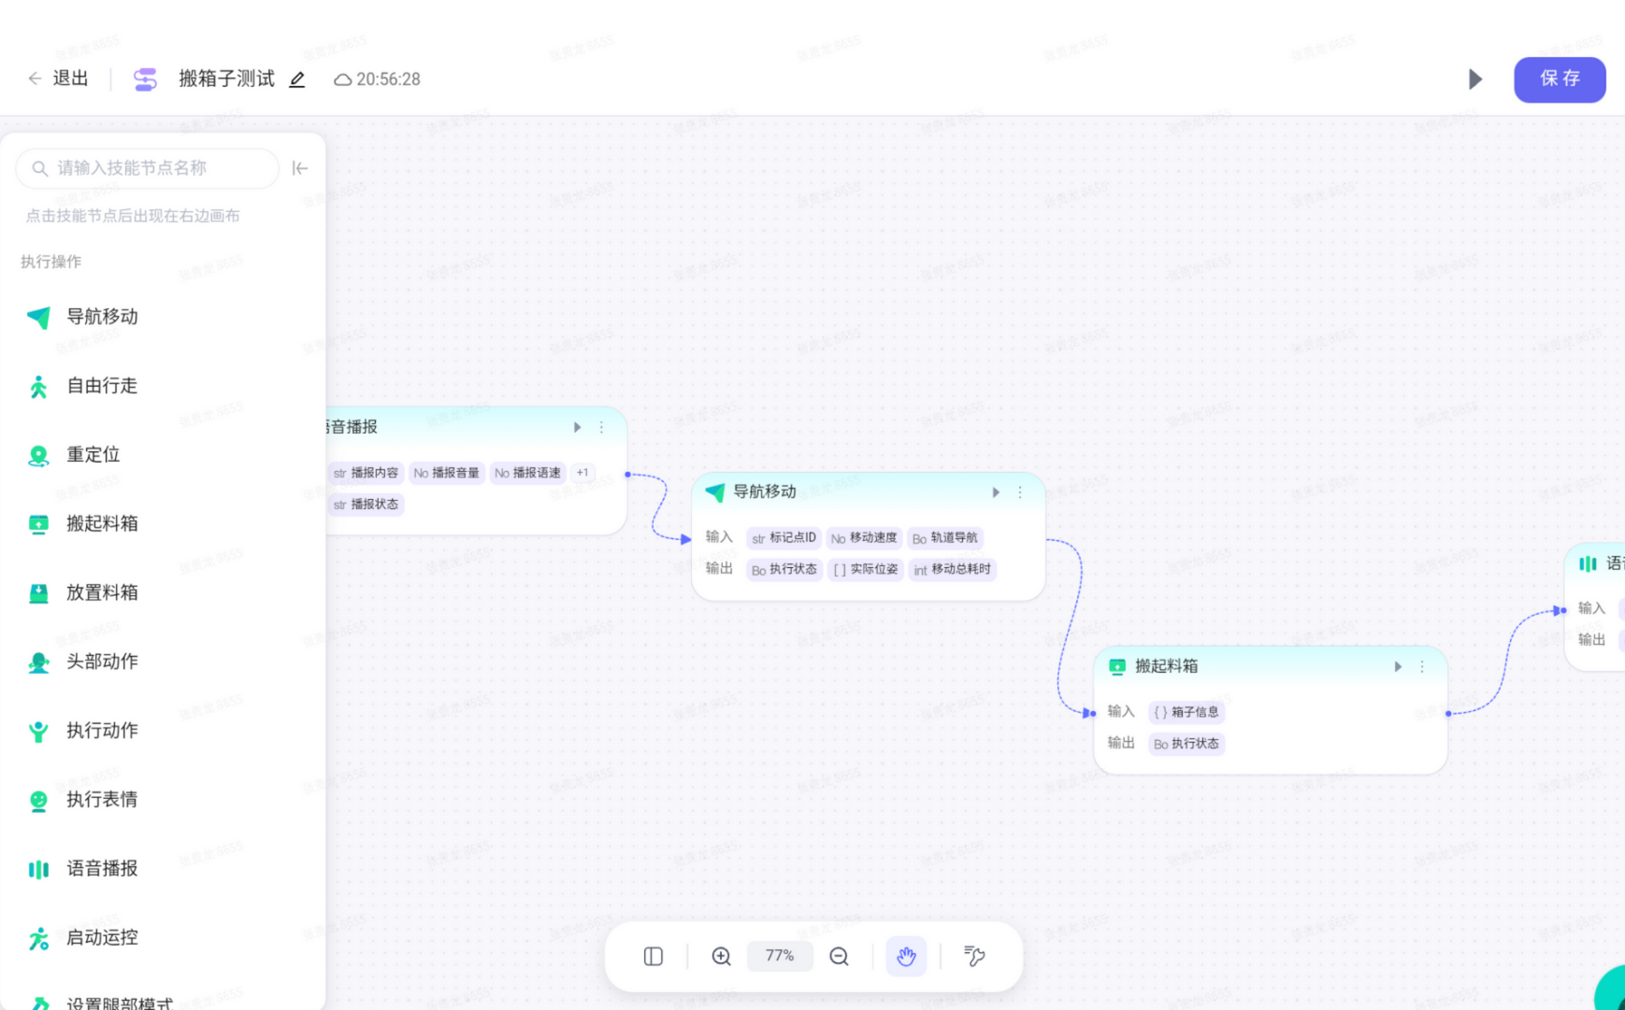
Combined with the robot's skills in the skill management module and the skill capabilities reported by the robot, workflows can be configured by drag-and-drop. The configured workflows can be referenced in the task management module to invoke the corresponding atomic capabilities to execute tasks, mainly used in industrial robot operation scenarios such as box handling, loading/unloading, and palletizing/depalletizing.
（6）Operation & maintenance management
Displays the current version numbers of all firmware of the robot body
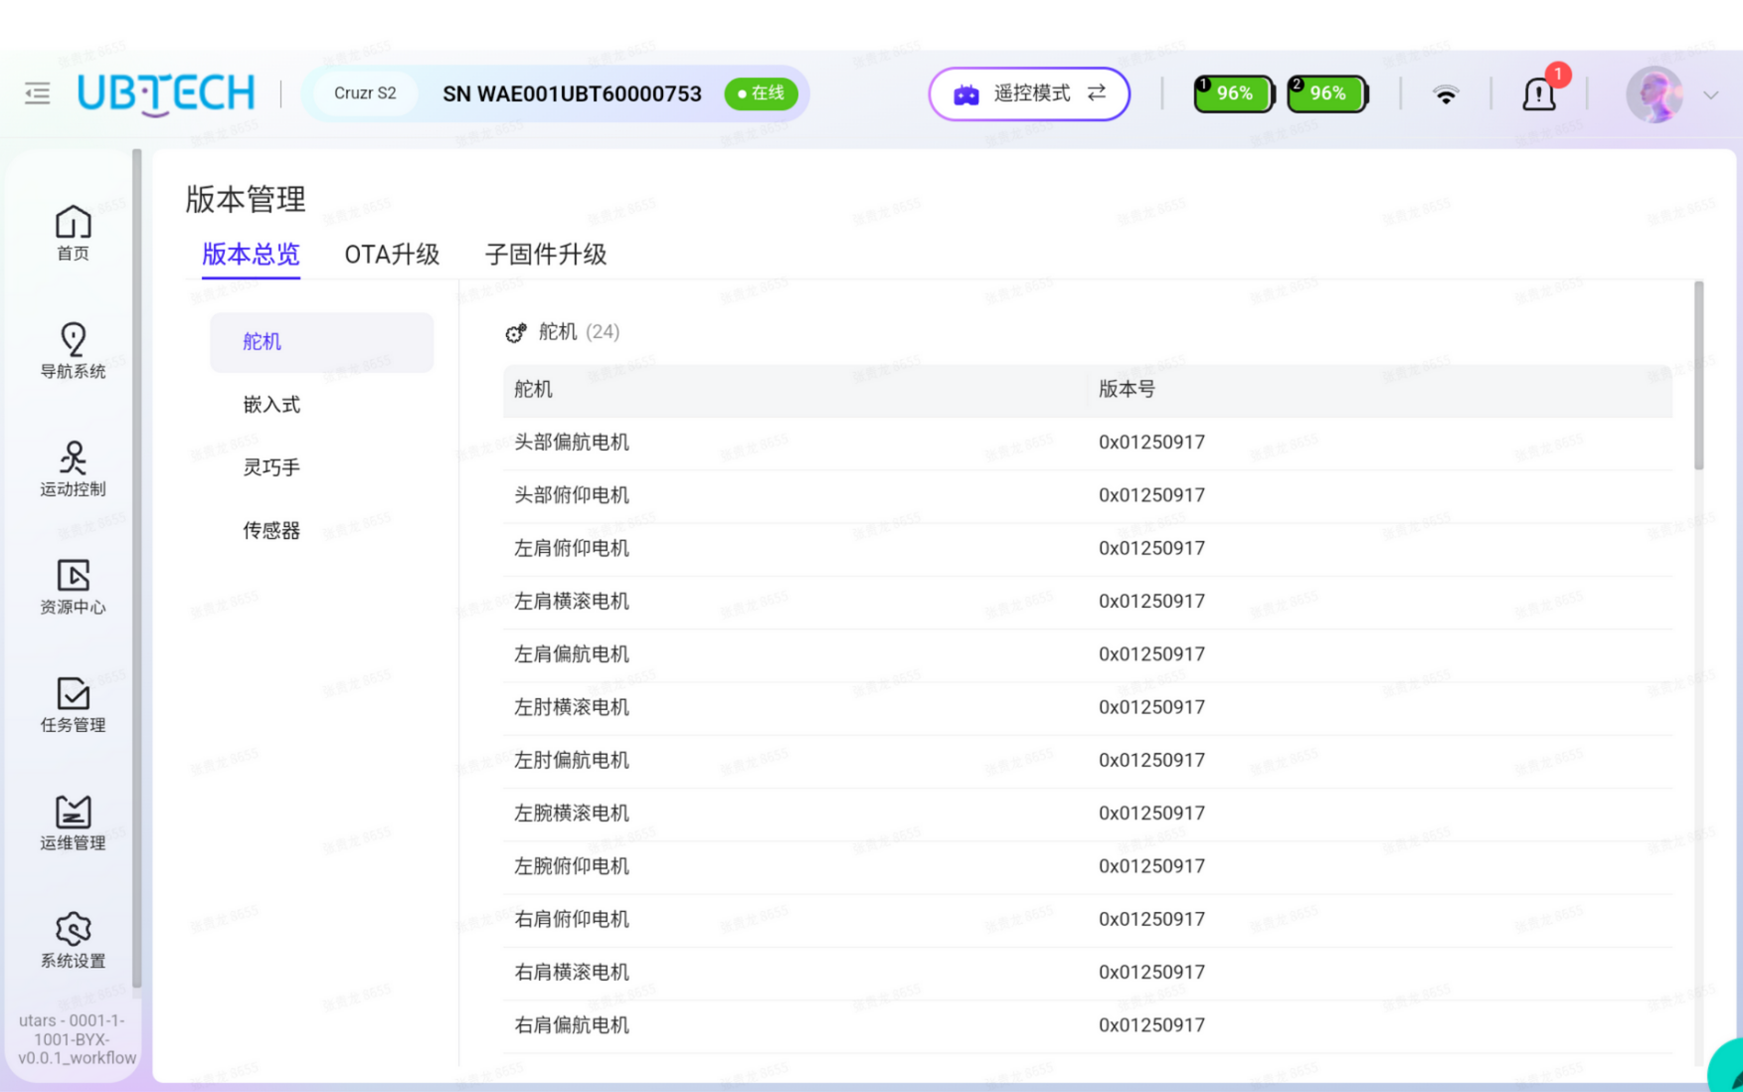
（7）The OTA upgrade page shows the current version numbers of the system version and firmware version. If there is a new upgrade report, the upgrade package list appears here; overseas, offline package upgrade is generally used.
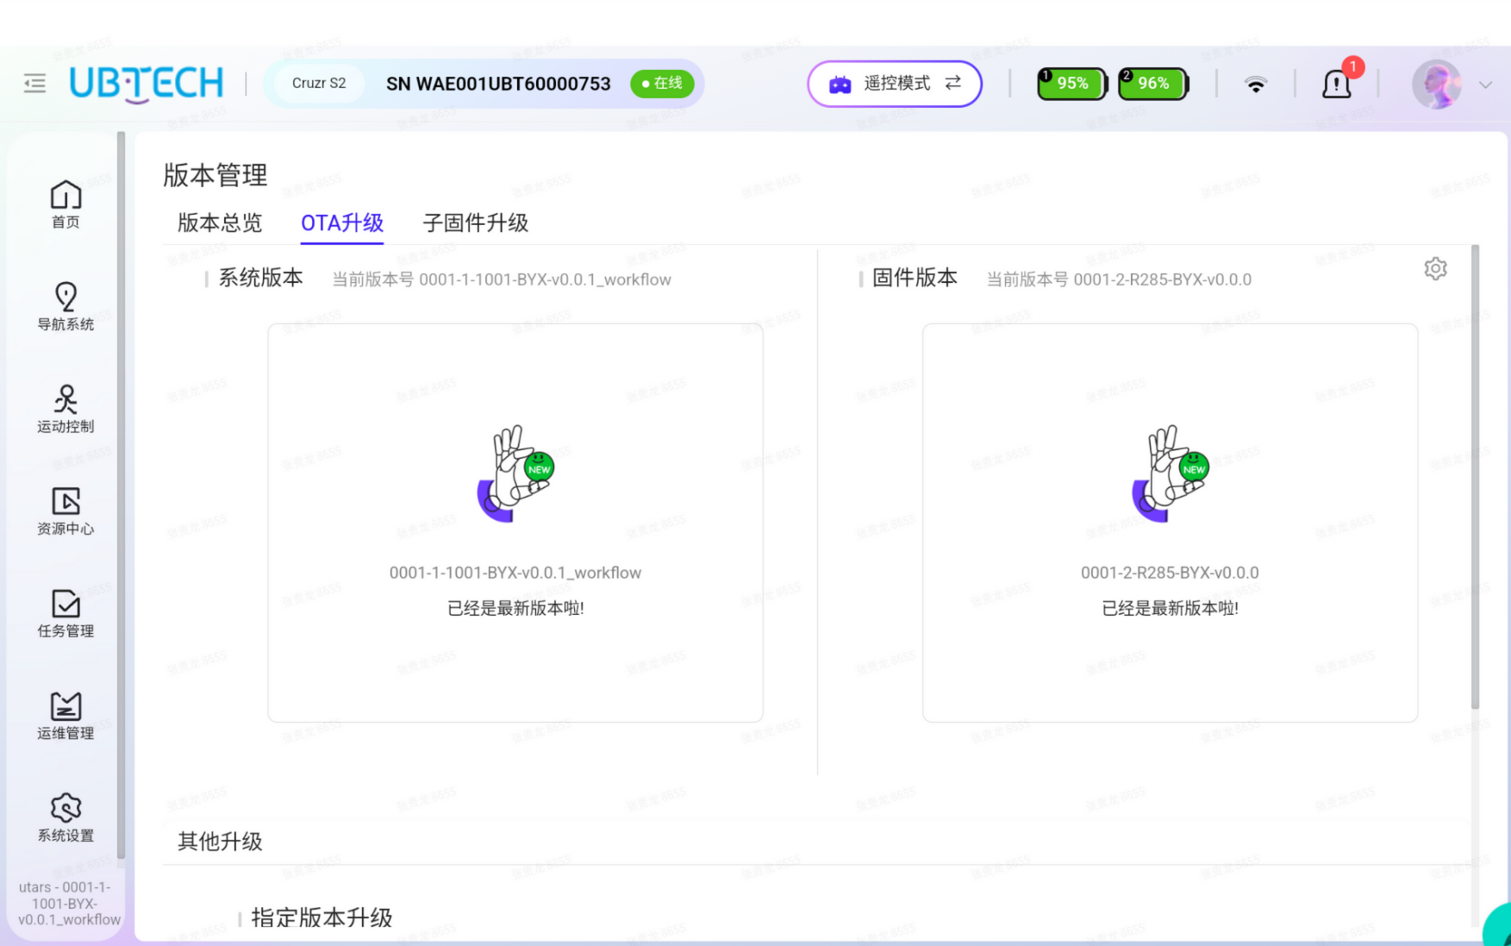
（8）When the robot fails, it reports the fault. The current fault page displays the faults occurring on the robot. You can view the fault system, cause, and solution. After being handled, the fault moves to the history fault page and the fault end time is shown.
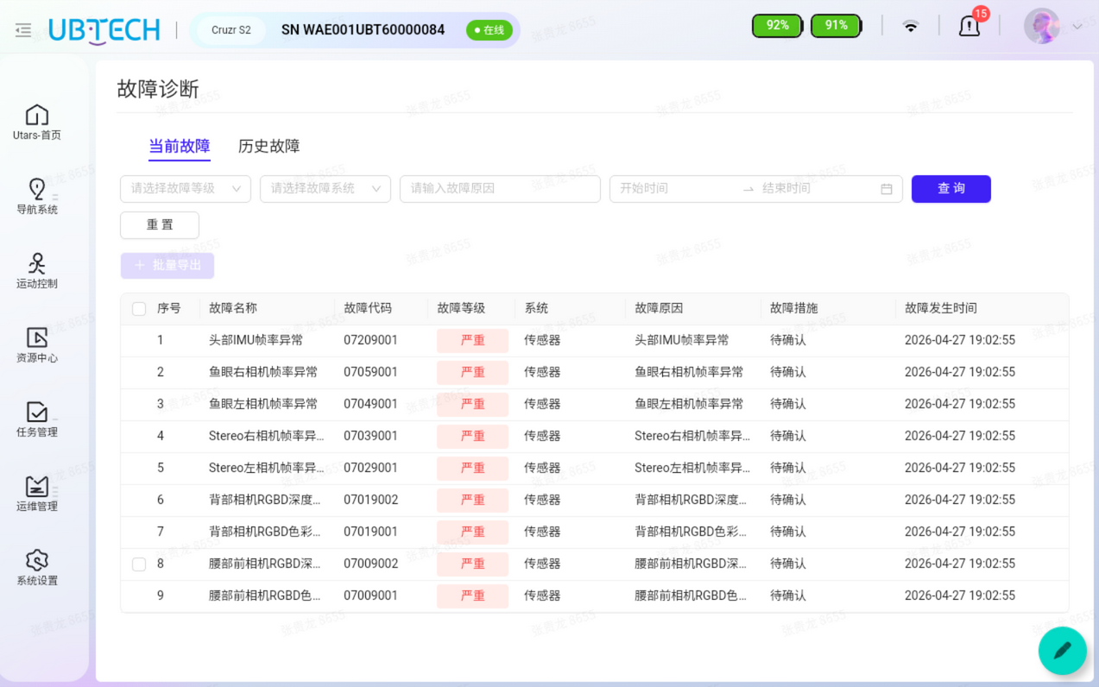
（9）Audio and video streaming
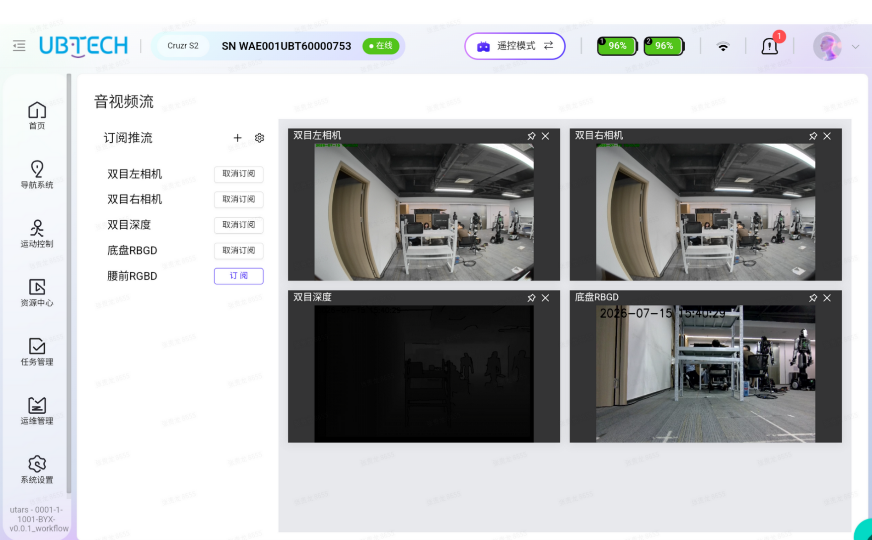
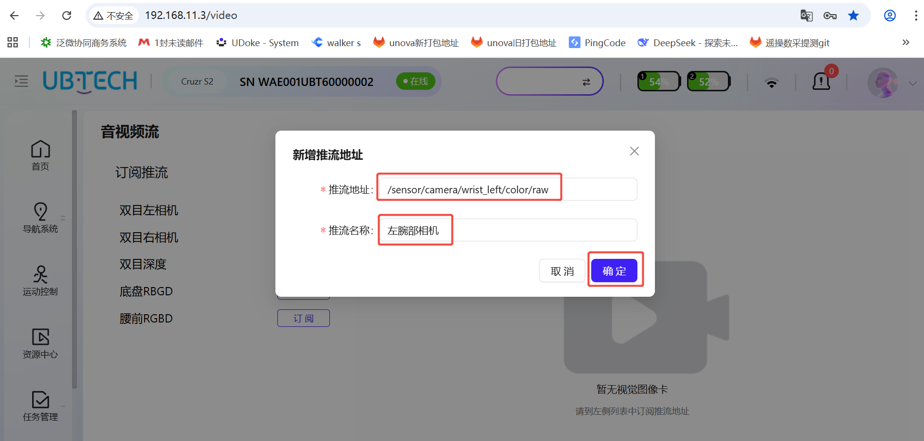
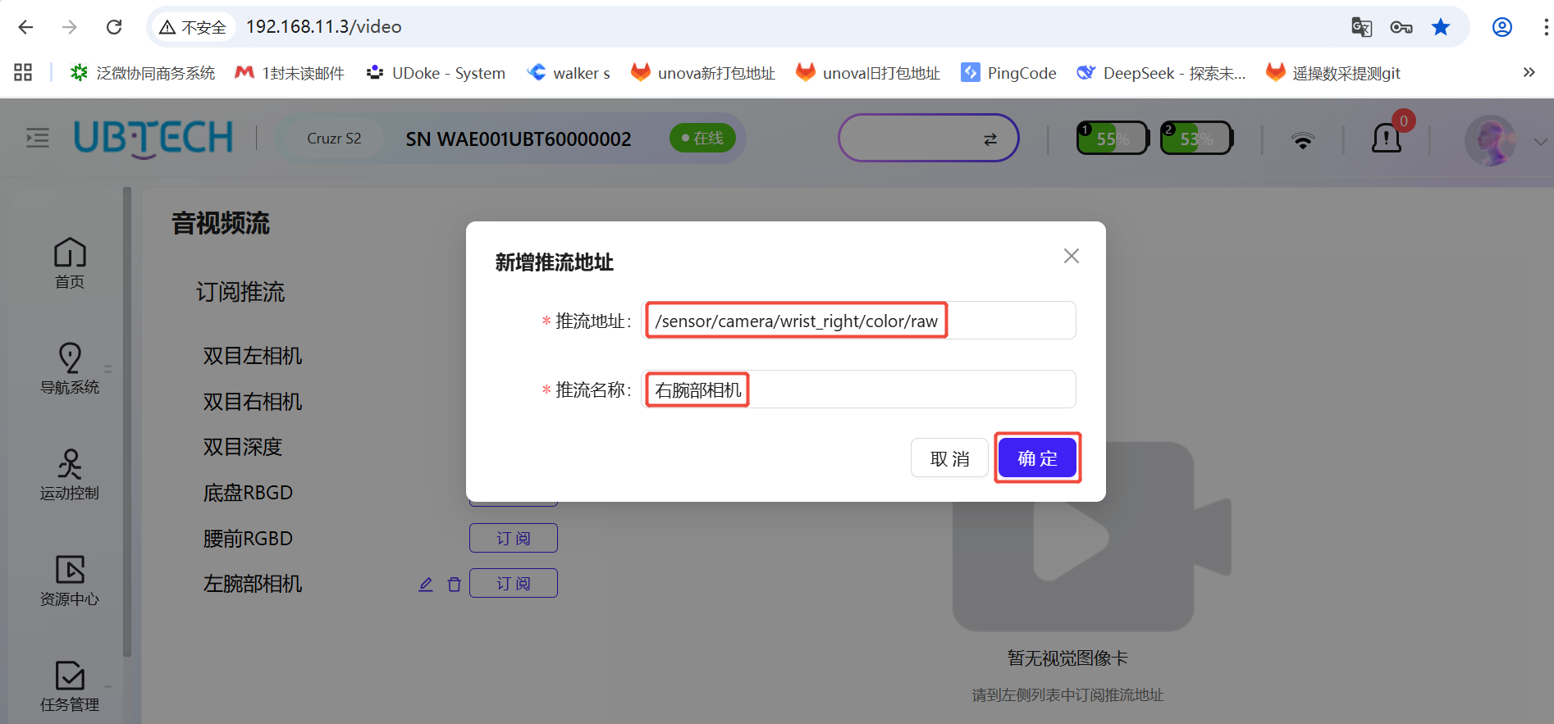

（10）Robot logs
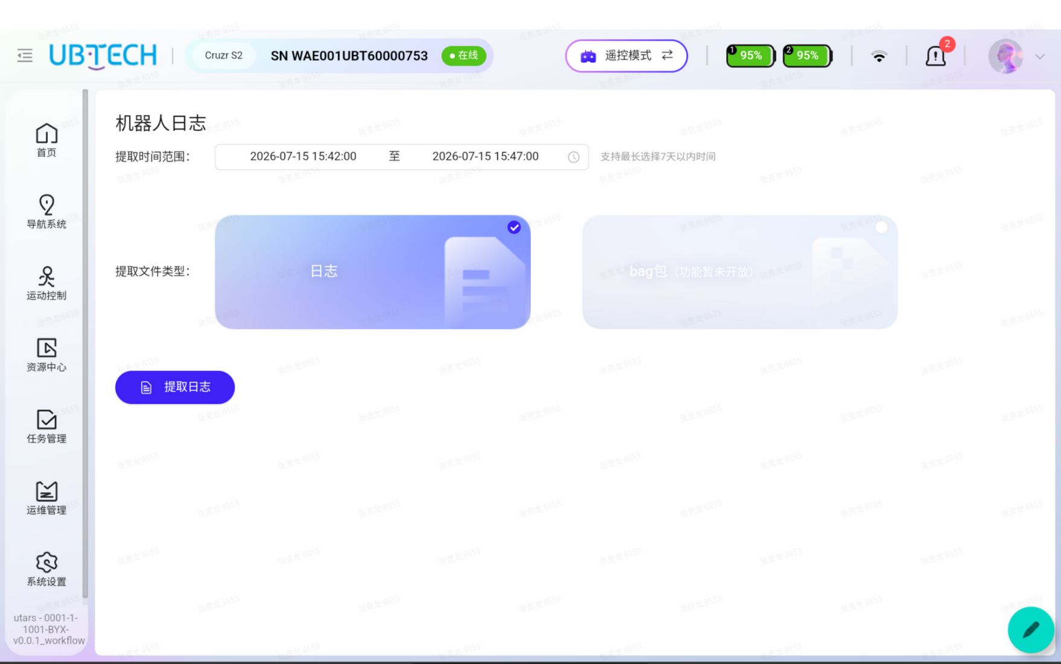

12.【Configure the Map and Charging Pile Task】
Enter UDoke http://192.168.11.2:9000 Account: walker Password: Walkerubtnb666, then in the top-left corner: Vision -- walker -- system (second page) -- the 【Edit】 dialog box on the right.
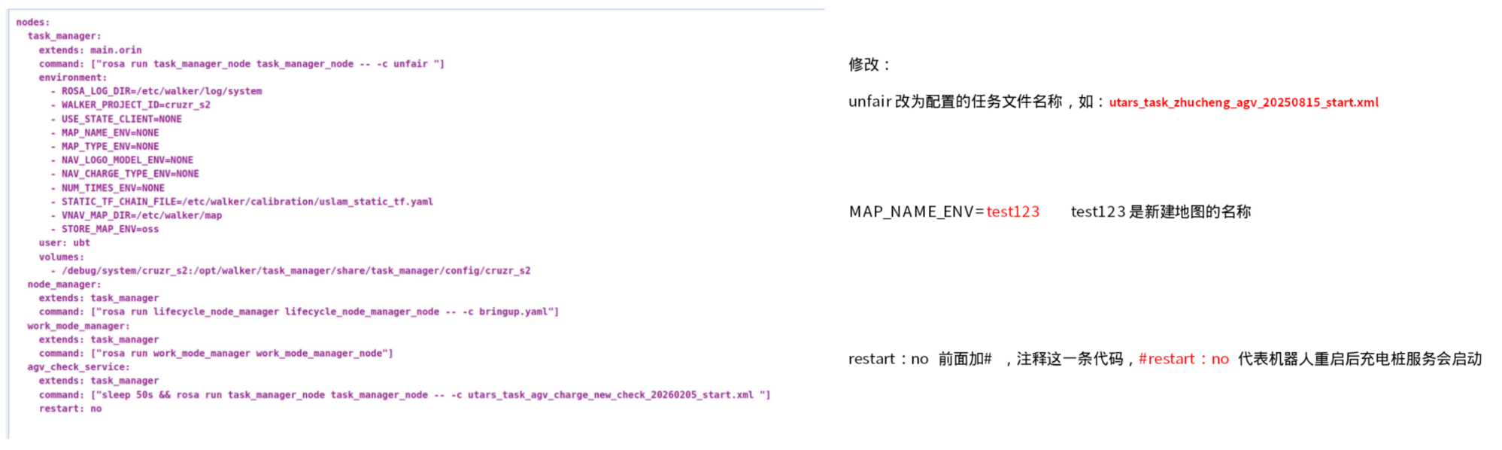

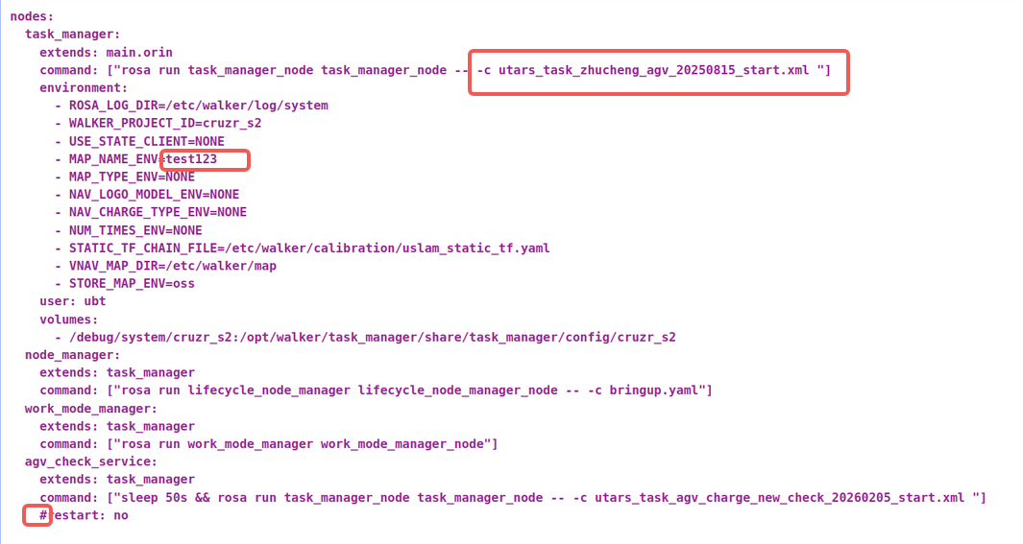
Then click【Confirm】. Make surethe entered content has no extra spaces or missing spaces, and pay attention to the format.

Shutdown and restart: after power-on, the robot announces: charging pile service has started, starting self-check, self-check passed, motion control enabled, then announces: setting map, localization succeeded. Then the robot automatically navigates to the charge0 point to stand by. When the battery level is below 80%, the robot automatically docks to charge; when it is above 80%, the robot stands by at the charge0 point. If it receives a task, the robot executes the task; when the battery level is below 40%, the robot does not execute tasks.
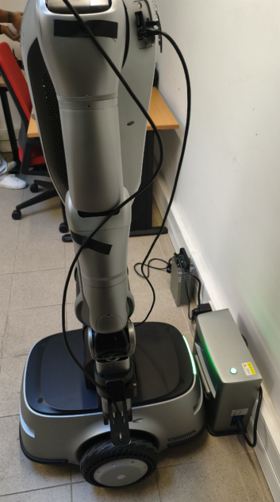

13.【Battery Level Announcement】
After the robot is fully powered on, press the 【Soft Switch】 on the right side once, and the robot announces the battery levels of the two batteries.
Enter UDoke (http://192.168.11.2:9000Account: walker Password: Walkerubtnb666), go to UDoke -- vision -- voice -- speech, and open the 【Log】 on the right to see the printed voice text announced by the robot; currently it is all displayed in Chinese.

14.【Emergency Button】
（1）【Remote Control Mode】At close range, use the emergency button on the back. When the robot becomes abnormal, press the emergency button in time and the robot freezes. The robot needs to be powered off and restarted (release the emergency button in advance).
（2）【Remote Control Mode】At long range, press the remote-control lever F down + C, and the robot enters damping mode. After handling the abnormal situation, press F up + C to exit damping mode, then press the robot's rear emergency button once again and rotate it to release, then press F down + D to enable motion control. Note: if the robot's arm is close to the robot body, it is recommended to power off and restart the robot; otherwise, after the robot performs the zeroing motion, the gripper may scrape the robot shell and cause damage.

15.【Replacing the End Effector】
The dexterous hand or two-finger gripper must be replaced with the robot powered off. After replacement, power on the robot; you need to modify the environment variables and then restart the container for the configuration to take effect.
EnterUDoke (http://192.168.11.2:9000 Account: walker Password: Walkerubtnb666) UDoke -- Env

Different end effectors are configured through HW_TYPE. The following are the configuration values corresponding to different end effectors:
3rd/4th-gen dexteroushand --- cruzr_s2_v1_sps
Dahuan two-finger gripper/ electric cylinder --- cruzr_s2_v1_gripper
Clampingplate --- cruzr_s2_v1 (default)

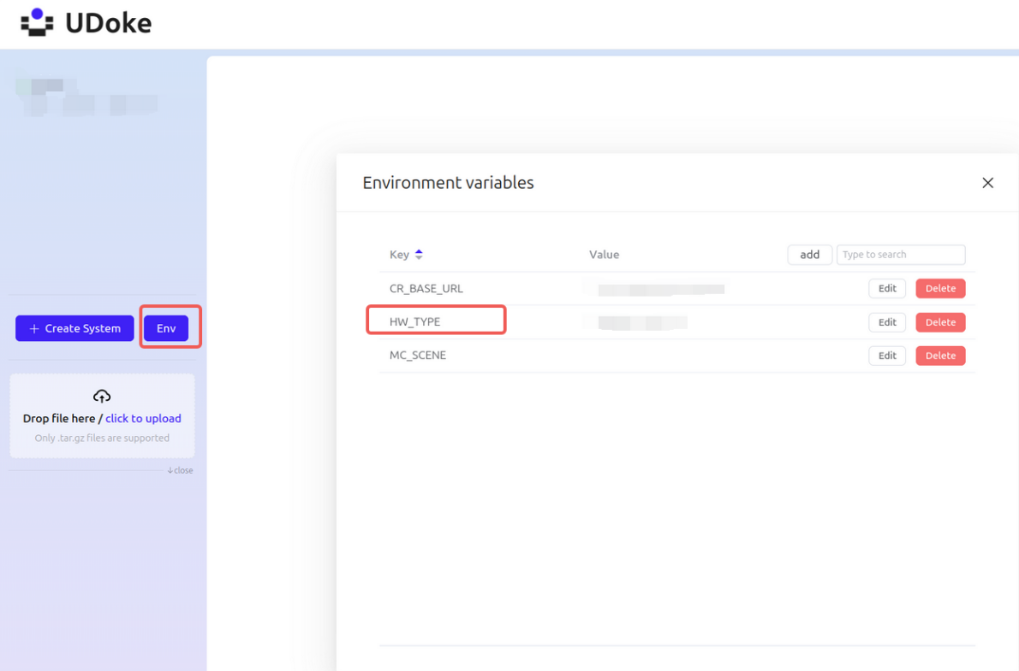
【Making the Configuration Effective】
Modifying only the ENV configuration will not take effect. You need to re-upload the vision and motion containers in the following way for it to take effect:
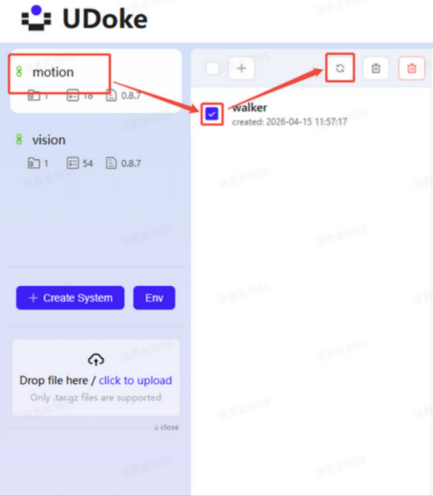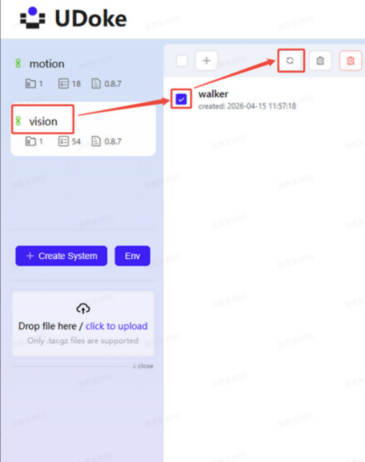

16.【Mode Switching】
After power-on, the robot defaults to 【Remote Control Mode】. You can go to http://192.168.11.3 (Account: UBTNB Password: ILOVEUBT) to switch to 【Developer Mode】, 【Teleoperation Mode】, etc.
Remote Control Mode --- Control Mode
Developer Mode --- Developer Mode

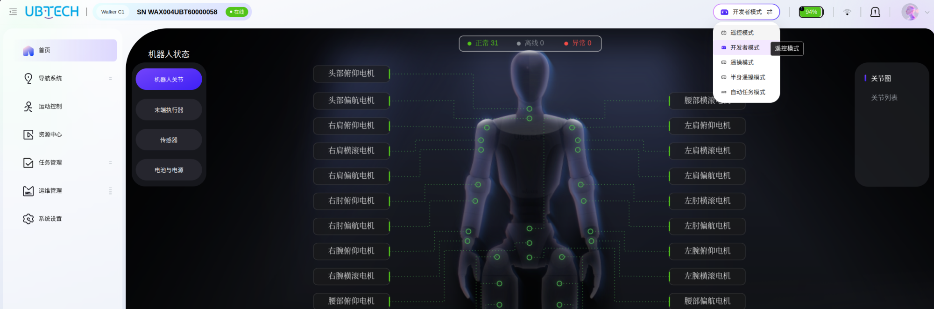

17.【Configure the Box-Handling Task】 ----- Rail Navigation

Preparation conditions:
（1）Two racks (120/150 L x 50 W x 150 H cm)
（2）Two boxes (40*30*23 cm, with straight edges)
Box requirements:
Size: squareboxes with a brim on the edge, so that the hook of the robot gripper can catch the box and prevent it from falling. The box height must not be too high; otherwise, when the robot carries the box, it will block the binocular camera on the head or the RGBD camera on the waist.
Color: currently blue, gray,black,and green all work; white, red, and yellow should also work, but these bright-colored boxes may sometimes be overexposed.
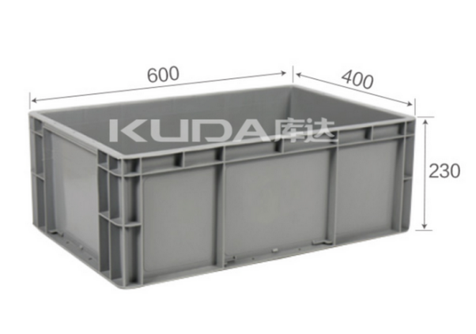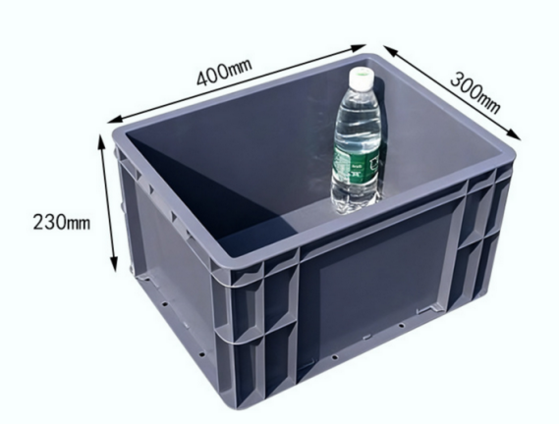
We have collected alarge amount of data on the above two box sizes (VLA model). When the robot picks up a box, it uses vision to recognize the box's L x W x H, and then calculates the positions of the robot's two grippers on both sides of the box.
Boxes of other sizes are also acceptable, but it is best that the box edges are straight and the box has a brim, making it easier for the robot to grip and carry the box.
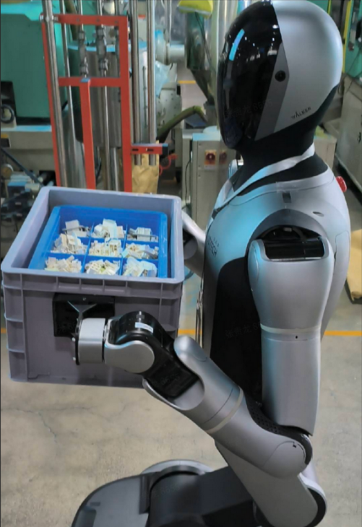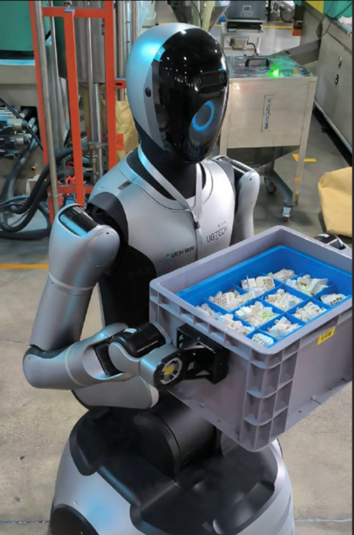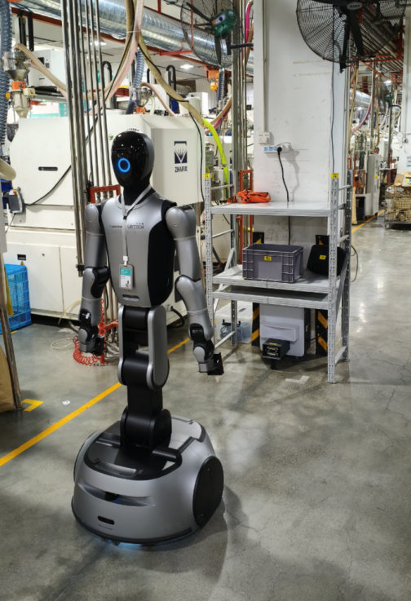
As shown, a 40*30*22 cm box
Theconfiguredbox-handling task is utars_task_zhucheng_agv_20250815_start.xml (rail navigation)
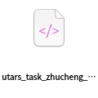
Taskflow:
1. The robot stands by in front of rack A (charge0), and the charging pile is below rack A;
2. When the robot receives the task, it executes the box-handling task and announces: setting map, localization succeeded. Then the robot moves to the low-position box of rack A, moves along the rail to the low position of rack B, takes the empty box at the high position of rack B, moves back along the rail to rack A, and puts the empty box back at the high position of rack A.
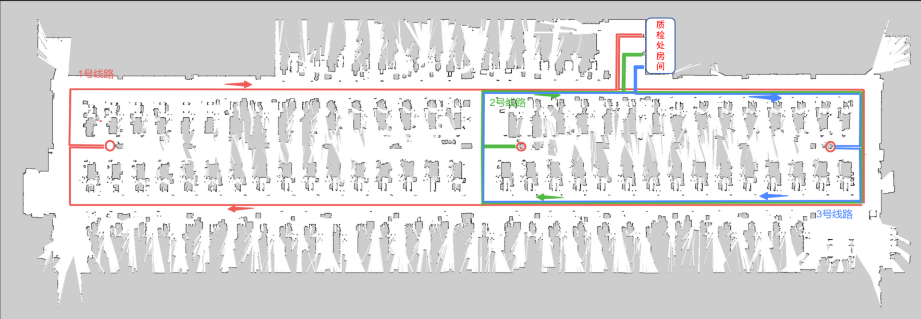
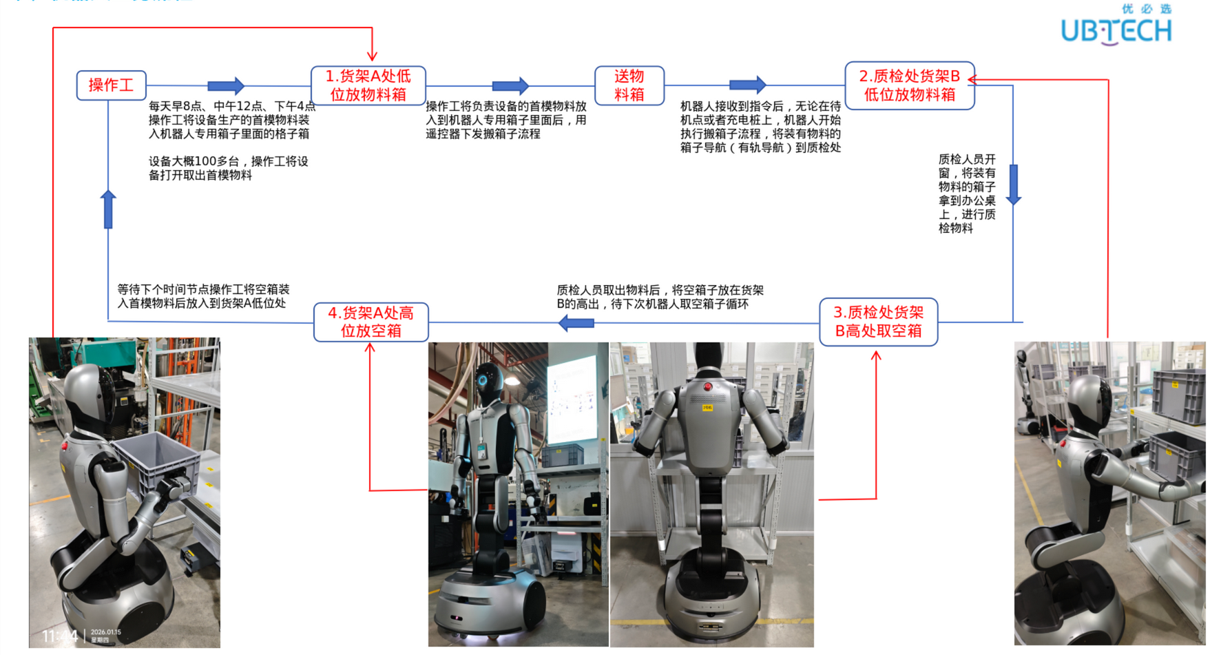

Mapping flow:
After opening the webbackend page http://192.168.11.3 (Account:UBTNB Password: ILOVEUBT), go to 【Navigation System】-【Map Management】, thenstart 【Mapping】. Enter a map name, then scan the map clockwise or counterclockwise. If the map is large and has ring structures, map slowly and rotate slowly at corners. After returning to the starting position, travel a distance along the same path (repeating part of it) to complete loop closure of the map. You can see the map refresh and complete the loop, then save the map.

Point-placementflow:
Because it is rail navigation, pointsneed to be placed in front of rack A: get1 (1), put1 (2), 3, 4, 5, 6; and in front of rack B: put2 (7), get2 (8), 9, 10, 11.
RackA: lower layer get1(take the low-position loaded box), upperlayer put1 (place the high-position empty box)
RackB: lower layer put2(place the low-position loaded box), upperlayer get2 (takethe high-position empty box)
The robot is centered in front of the rack, and the bottom protrusion (center of the collision strip) is aligned with the center of the rack.
get1：12.5cm put1：33.5cm
get2：12cm put2：31cm
Make sure the robot's point is at the exact center of the rack with no angular deviation (control the robot remotely from far away along the vertical centerline oftherack to near the rack).

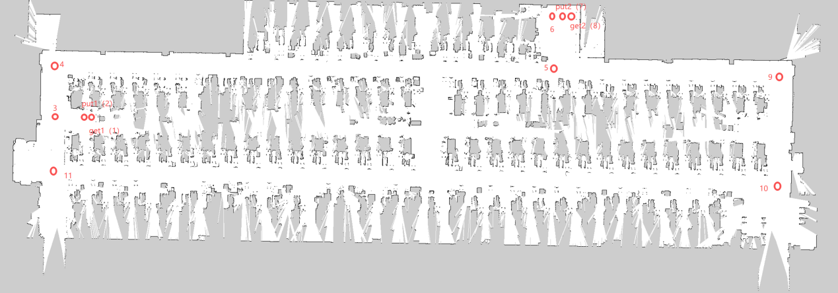

Robotmovement rail path:
The robot grips the low-position box of rack A at the 【get1】 point ----- passes 【put1】 ----- passes 【3】 ----- passes 【4】 ----- passes 【5】 ----- passes 【6】 ----- places the low-position box at 【put2】 of rack B ----- takes the high-position empty box at 【get2】 of rack B ----- then passes 【put2】 ----- passes 【6】 ----- passes 【5】 ----- passes 【9】 ----- passes 【10】 ----- passes 【11】 ----- passes 【3】 ----- places the high-position empty box at 【put1】 of rack A
If an obstacle is encountered during rail navigation, the robot stops; after the obstacle is removed, the robot continues rail navigation.

Configure the map rail:
Configure the umap.json file in the robot's map (the json file content as shown below) to see the point information, and connect the abovepoints to form the robot's running rail. On http://192.168.11.3 (Account: UBTNB Password: ILOVEUBT), after 【Map Management】 -- loading the map, the rail will be displayed.
【Map Path】 ssh walker@192.168.11.3 (password: aa) Location: /etc/walker/map/. The map name can be changed. Open the umap.json file in the configured map umap folder to see the detailed point information; the point names can also be changed.
Execute the task:
With all remote-control levers in the middle position, power on. Push the E leverup and the G lever to the right; the robotannounces: setting map, then executesthe task, a complete flow (take full box at point A - place full box at point B - take empty box at point B - place empty box at point A), then return the E and G levers to the middle position.
【A Button】Press the A key to terminate the current task when the H key is in the middle (after the task flow is completed, pressing the A key allows remote control of the robot).
【Right Joystick】Push the joystick down and the robot squats. First make sure both arms are in the zero state and pointing outward; otherwise, the metal gripper will hit the shell when squatting.
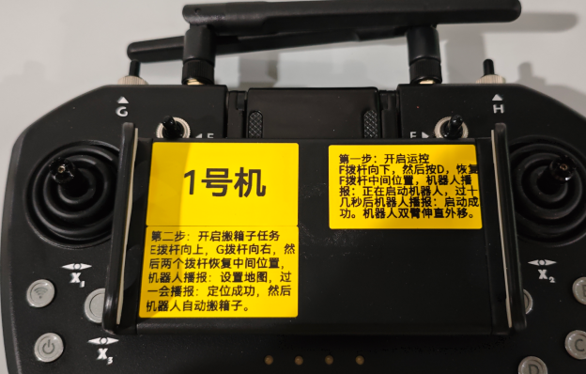

18.【Configure the Box-Handling Task】 ----- Free Navigation

Enter UDoke http://192.168.11.2:9000 Account: walker Password: Walkerubtnb666, then in the top-left corner: Vision -- walker -- system (second page) -- the 【Edit】 dialog box on the right.
Onlyconfigure utars_task_zhucheng_agv_nav_new_20260303_start.xml and the map tes123 (including get1, 2, put1,2points and the charge0 point)
RackA: lower layer get1(take the low-position loaded box), upperlayer put1 (place the high-position empty box)
RackB: lower layer put2(place the low-position loaded box), upperlayer get2 (takethe high-position empty box)
The robot is centered in front of the rack, and the bottom protrusion (center of the collision strip) is aligned with the center of the rack.
get1：12.5cm put1：33.5cm
get2：12cm put2：31cm
Make sure the robot's point is at the exact center of the rack with no angular deviation (control the robot remotely from far away along the vertical centerline oftherack to near the rack).
The get1, 2, put1, 2 points can be fine-tuned according to actual conditions.

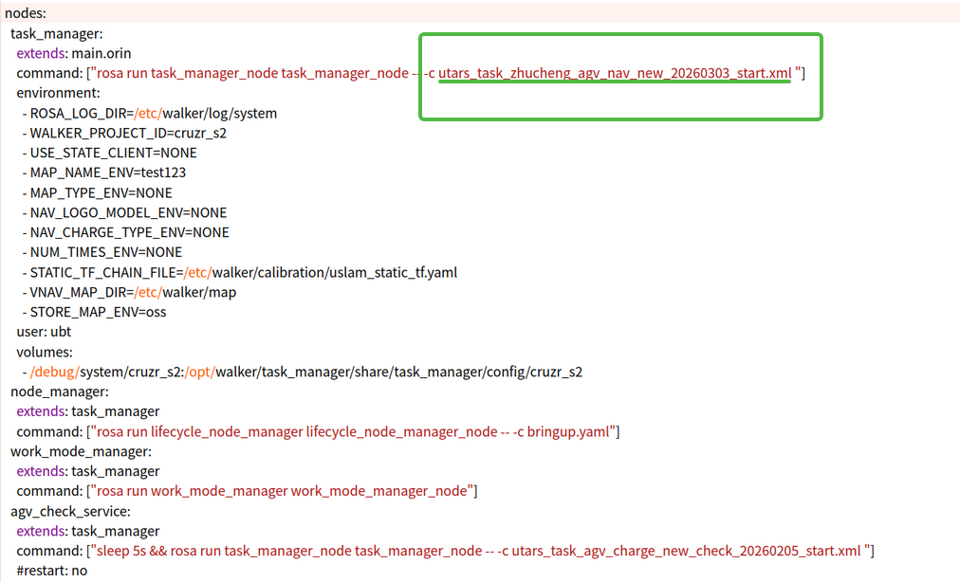

Robot movement path:
The robotgrips the low-position box of rack A at the 【get1】 point ----- places the low-position box at 【put2】 of rack B ----- takes the high-position empty box at 【get2】 of rack B ----- places the high-position empty box at 【put1】 of rack A
The robot navigates freely between the two racks. During free navigation, if an obstacle is encountered, the robot goes around it.

19.【Configure Folder Permissions】
Use MobXterm to open 192.168.11.3 Account: walker Password: aa. Configure permissions for the new folder. If a new folder is created under etc/walker, permissions must be granted. Command: sudo chown 1000:1000 -R /etc/walker

20.【Mounting Files】 ----- Box-Handling Task Files
Meaning of mounting files: by default, task files are integrated inside the robot's internal files. If modification is needed, you have to modify the corresponding internal files of the robot, which is inconvenient. Files can be mounted to make configuration modification easier.
For example, for the free-navigation task file utars_task_zhucheng_agv_nav_new_20260303_start.xml, mounting is the most convenient wayto modify its configuration content.
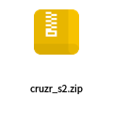
（1）First unzip cruzr_s2.zip, then place the cruzr_s2 folder in the 192.168.11.3 /debug/system directory.
（2）The utars_task_zhucheng_agv_nav_new_20260303_start.xml file is inside the cruzr_s2 folder.
（3）Enter the 【web】UDoke 192.168.11.2:9000 (Account: walker Password: Walkerubtnb666) Vision -- walker -- system -- edit on the right.
volumes:
- /debug/system/cruzr_s2:/opt/walker/task_manager/share/task_manager/config/cruzr_s2
Before mounting
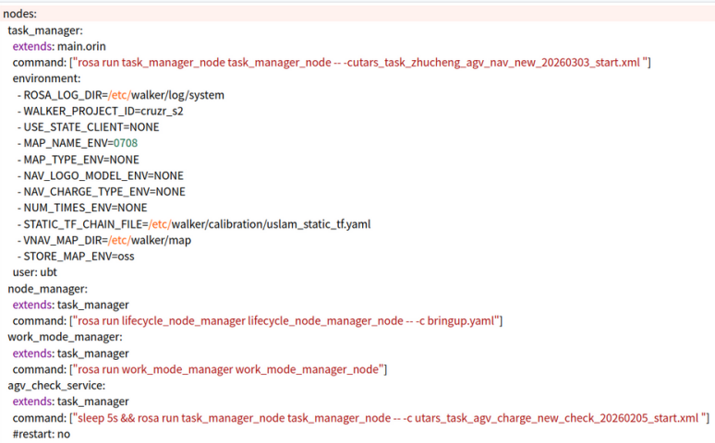
After mounting Pay attention to the format; if the format is wrong, an error will be prompted after Confirm.
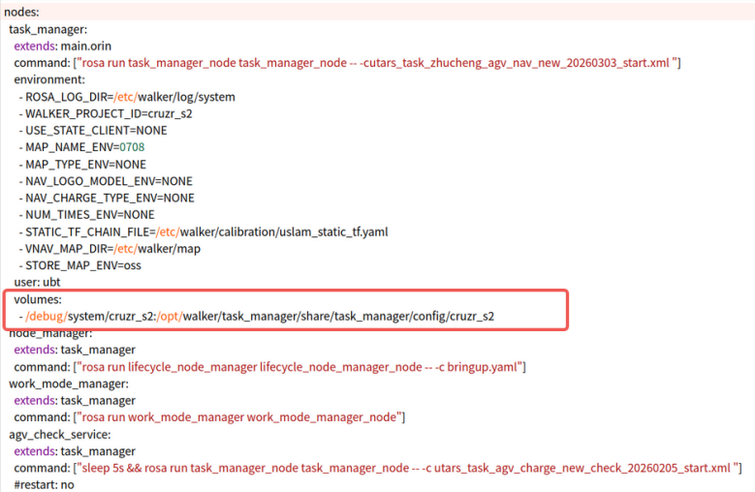

21.【Mounting Files】 ----- Charging Pile Task Files
1. Place the charging pile file (utars_task_agv_charge_new_check_20260205_start.xml) in the 192.168.11.3:/debug/system/ directory.
2. Enter the 【web】UDoke 192.168.11.2:9000 (Account: walker Password: Walkerubtnb666) Vision -- walker -- system -- edit on the right, and find agv_check_service:
3. Below #restart: no, add the following code. Pay attention to the format, then confirm. In the /debug/system/ directory, modify the 80%charging threshold in the charging pile file.
volumes:
- /debug/system/utars_task_agv_charge_new_check_20260205_start.xml:/opt/walker/task_manager/share/task_manager/config/cruzr_s2/utars_task_agv_charge_new_check_20260205_start.xml:rw
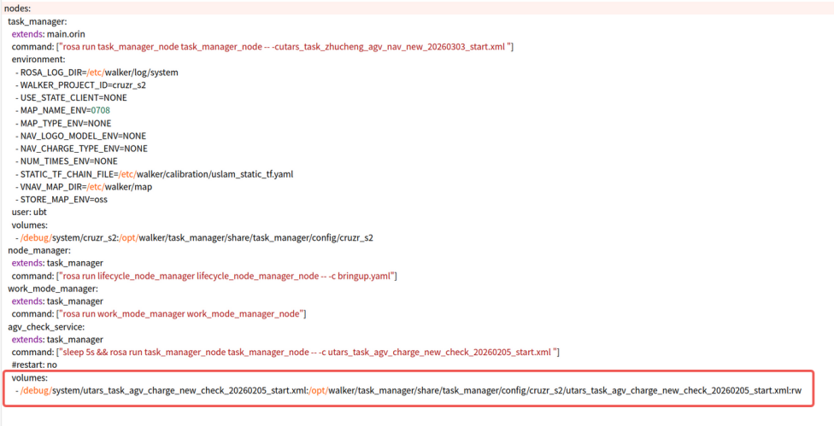
Currently the robot stands by at the charge0 point. When the battery level is below 80%, the robot docks to charge. You can modify this threshold in 192.168.11.3:/debug/system/utars_task_agv_charge_new_check_20260205_start.xml.

22.【Configure Box Size and Rack Height】
You can configure the corresponding box size and rack-layer height in the task file according to the actual box size and the actual height of the rack layer for taking/placing boxes.
For the box-handling task configured by mounting, refer to item 17.
ssh walker@192.168.11.3 Password: aa. Open and modify the utars_task_zhucheng_agv_nav_new_20260303_start.xml file in the /debug/system/cruzr_s2 directory, save it, andrestart the robot.
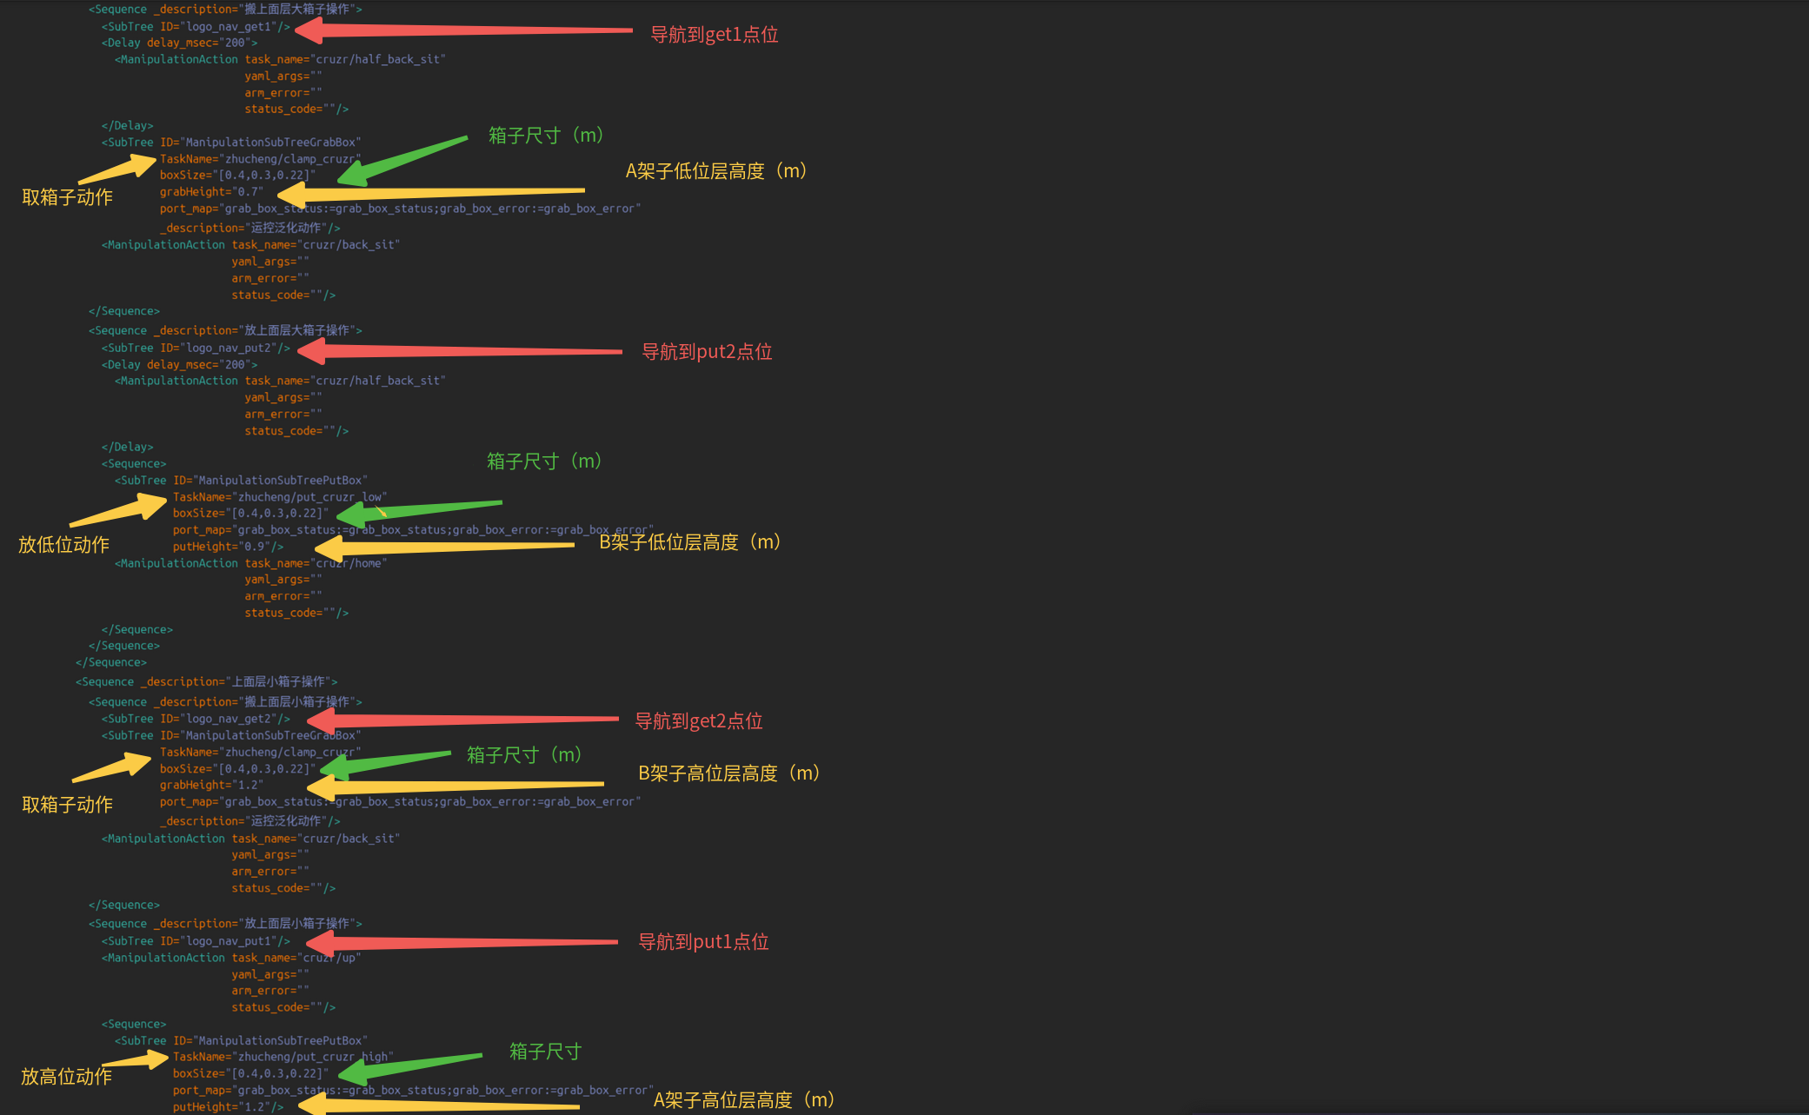

23.【Fine-Tuning the Robot Gripper Position】
Based on the actual box-gripping of the robot, fine-tune the position of the grippers on the sides of the box to ensure the box stays stable after the robot grips it. If the box contains a heavy object (the box including its contents should not exceed 10 kg; lighter items are recommended), during the gripping process, the weight of the box will cause it to sink and get caught exactly on the grippers.
Enter 192.168.11.2 Account: walker Password: aa
After enabling motion control, execute docker exec -it walker-motion.manipulation_robot_app-1 bash
cd /opt/walker/manipulation_meta_tasks/share/manipulation_meta_tasks/config/meta_clamp/zhucheng/

vim bodyback_cruzr_zc.yaml
vim clamp_cruzr_zc.yaml ---- configure the gripper position for taking a full (empty) box, the gripper 【relative position】 after 【visual recognition】
vim handsback_cruzr_zc.yaml
vim put_cruzr_zc_high.yaml ---- configure the absolute position of the gripper for placing an empty box (no vision)
vim put_cruzr_zc_low.yaml ---- configure the absolute position of the gripper for placing a full box (no vision)

For example: vim clamp_cruzr_zc.yaml ---- configure the gripper position for taking a full (empty) box, the gripper 【relative position】 after visual recognition
Position: [x, y, z] meaning of the corresponding values: x+ points toward the front of the chassis, y+ points toward the left of the chassis, z+ is vertical.
The upper part is the offset related to the left-hand gripping point.
The lower part is the offset related to the right-hand gripping point.
Actual reached position = box gripping point recognized by the camera + gripper start-to-end position + the corresponding offset value.

After the robot visually recognizes the box, the gripper positions on both sides of the box can be adjusted (fine-tuned). For example, the left gripper on the left side of the box is at 【0.005, 0.06, 0.02】, and the right gripper on the left side of the box is at 【0.005, -0.06, 0.02】.
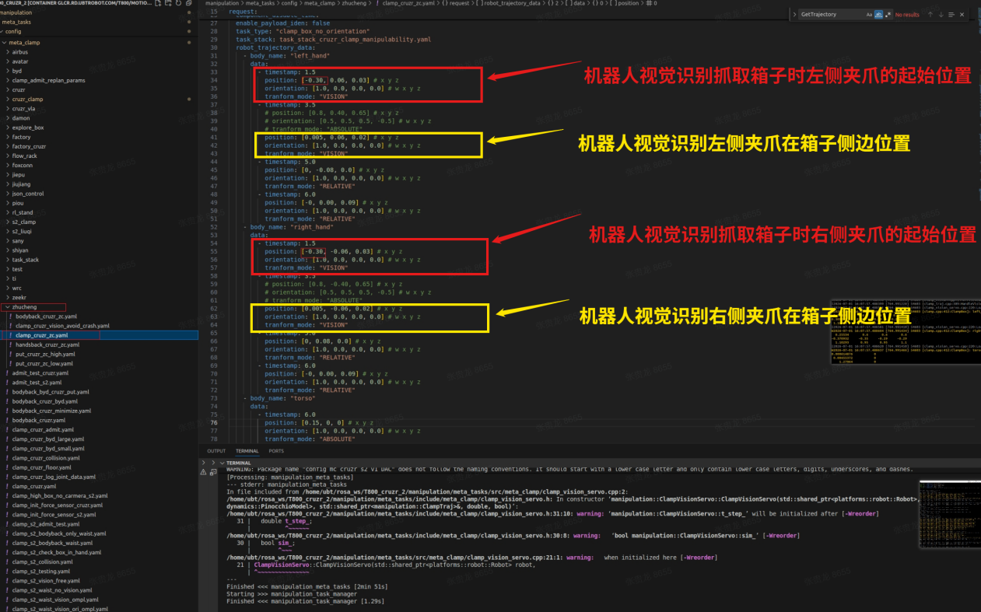
For example: vim put_cruzr_zc_high.yaml ---- configure the absolute position of the gripper for placing an empty box (no vision)
The red part is the left hand's three path points -> preparation position -> extend forward -> put down
The green highlighted part is the right hand's three path points -> preparation position -> extend forward -> put down
Position: [x, y, z] meaning of the corresponding values: x+ points toward the front of the chassis, y+ points toward the left of the chassis, z+ is vertical upward.
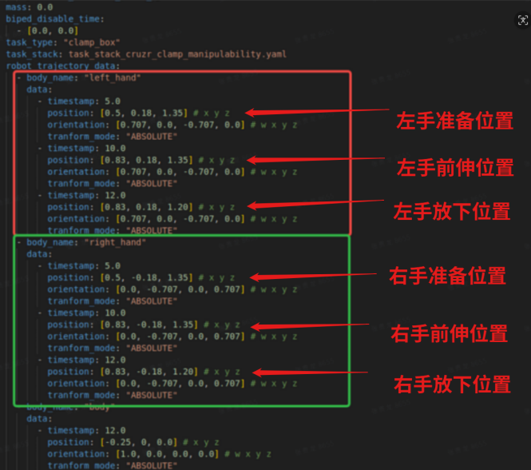

24.【Image of the Robot Recognizing the Box Dividing Line】
View the robot's vision images (generated after executing the robot's box-handling task).
sshwalker@192.168.11 /etc/walker/bag/vision/pose_6d_head_front. In two consecutivetime folders 1 minute apart, the images in the folder of the earlier minute contain visually annotated boxes.
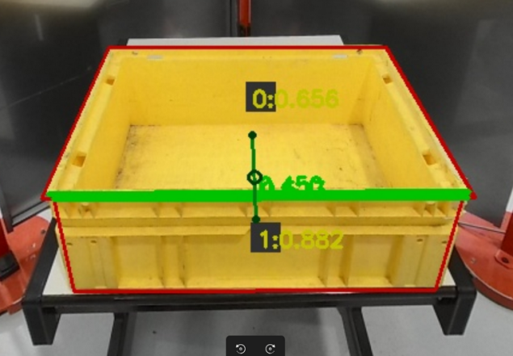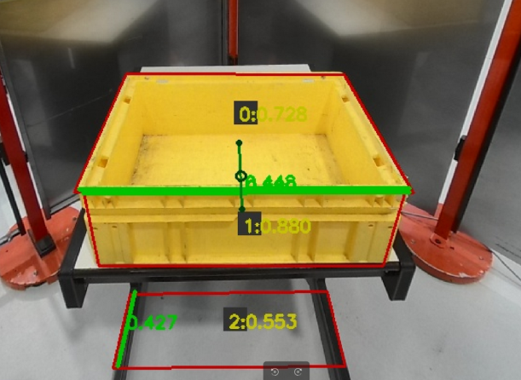The two legs of the rack are misrecognized as the box border length.
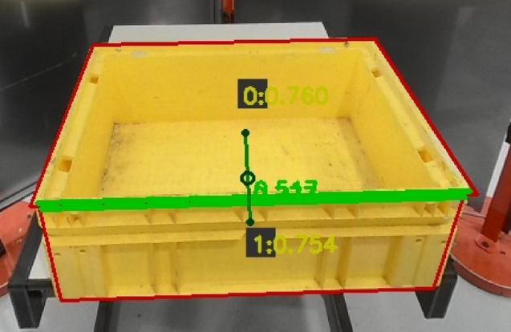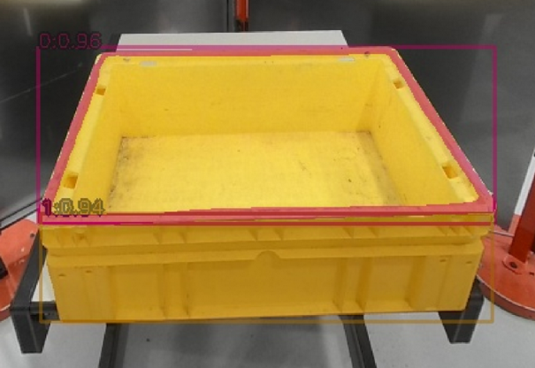

25.【Installing the Wrist Camera Wiring Harness of the Two-Finger Gripper】
Remote-control hex key set: H1.5 (for the ring of hex screws around the neck), H2 (for the hex screws connecting the front and rear shells of the shoulder), long-shaft hex key (6 hex screws outside the back shell / 6 hex screws inside the back shell), Phillips screwdriver (2 Phillips screws on the neck)
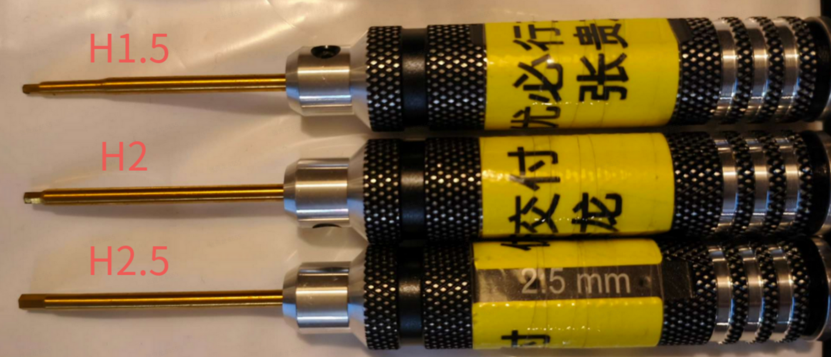
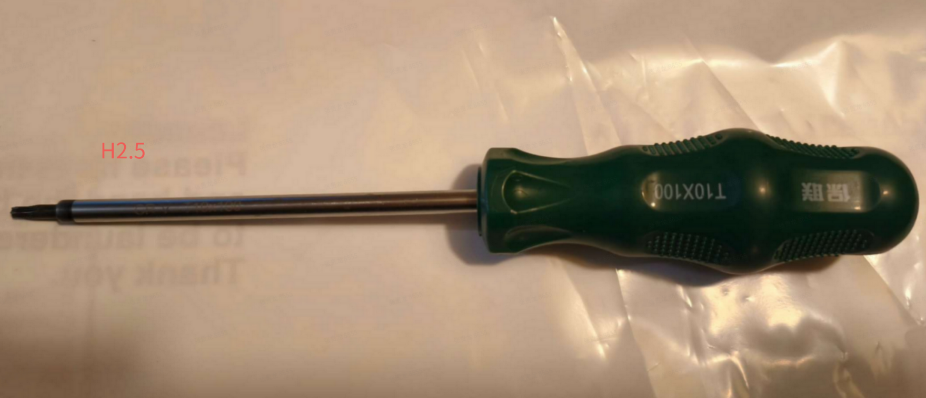

（1）Connect the left wrist camera to the type-C port on the right side of the back (the type-C on the right when facing the back of utars).
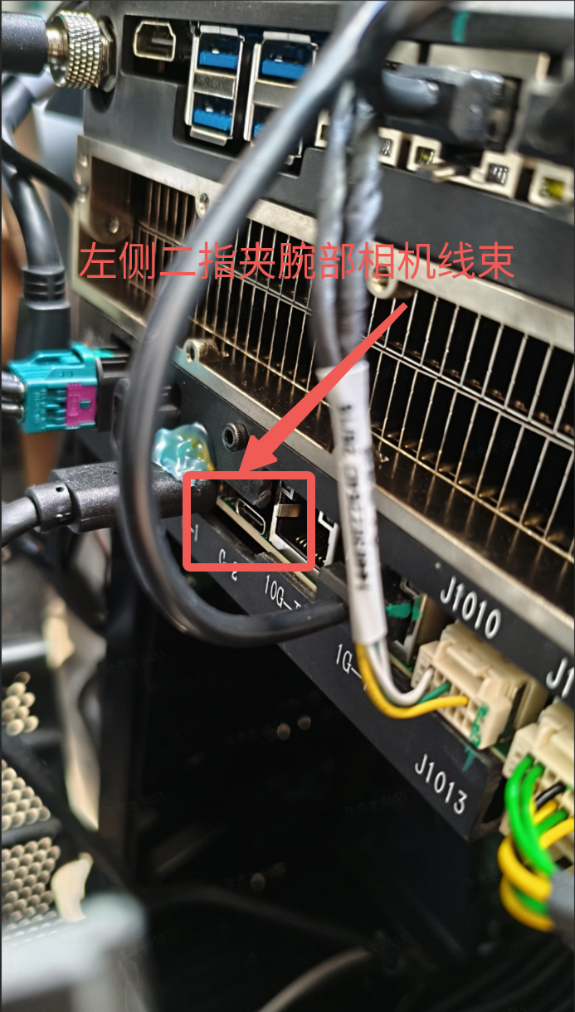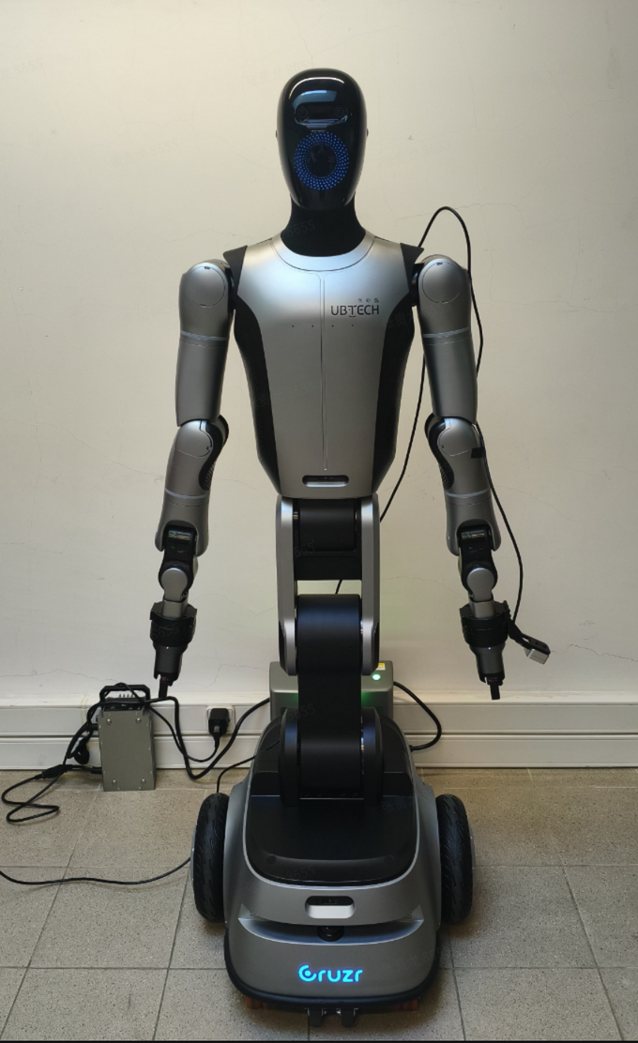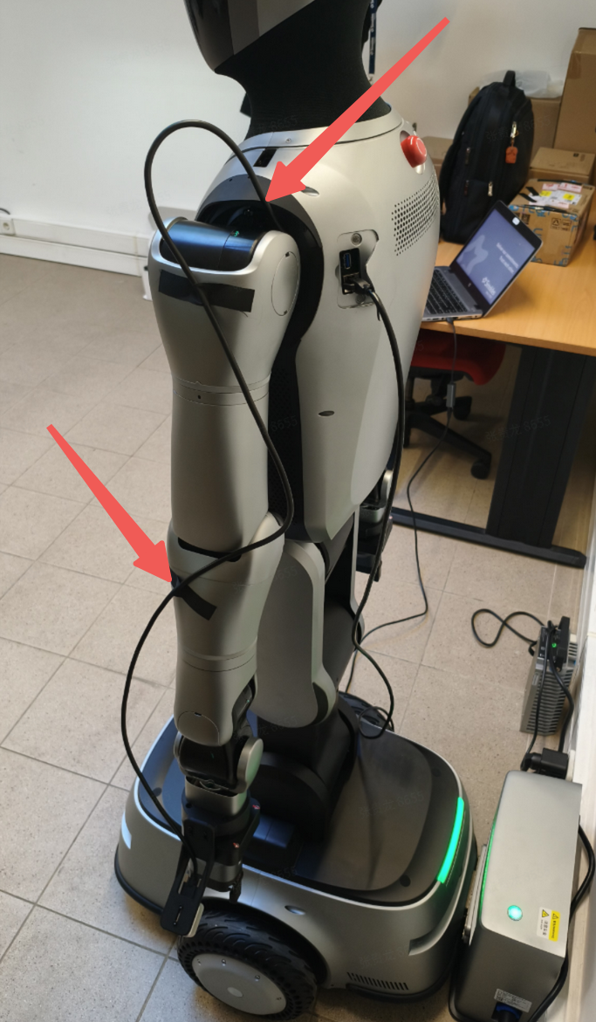
（2）Connect the right wrist camera to the front mainboard's USB-A-to-type-C adapter.
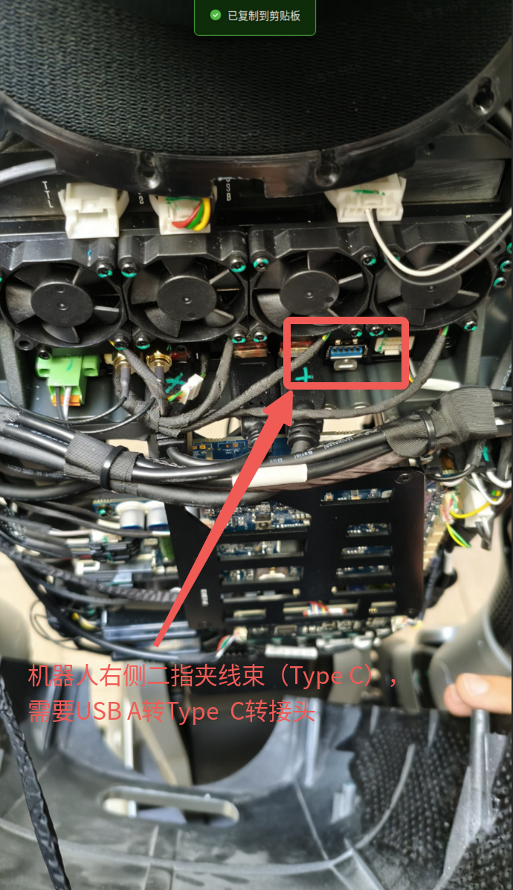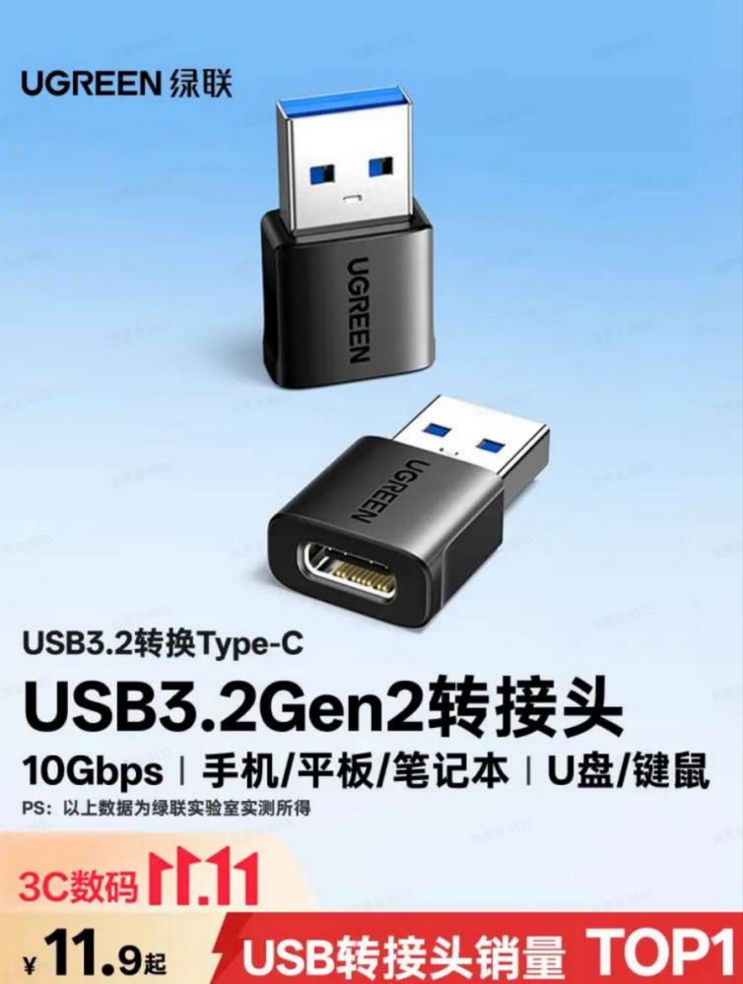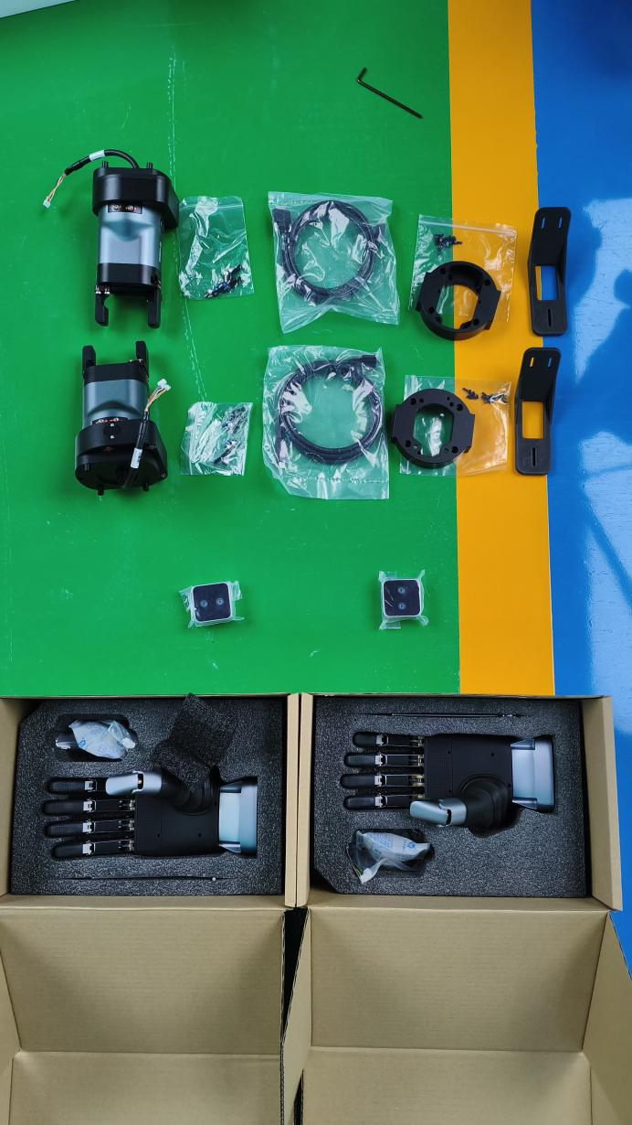

Note: leaveextra slack at each joint when installing the wiring harness, then fix it with acetate tape, to prevent the harness from being stretched when the robot's arm moves.

26.【Localization Loss in Large Venues and Solutions】
The venue environment has high similarity. If a task is started in a high-similarity area and the robot performs re-localization, it may cause localization deviation.
Problem analysis:
According to on-site feedback, previous navigation-task stress tests ran without problems, so the real-time localization of the localization algorithm can be ruled out. After that, issuing a navigation task near the newly added charging pile triggered re-localization and caused localization offset. Therefore, the main problem is that the similar laser structures when starting the task cause re-localization errors, as shown in the figure.
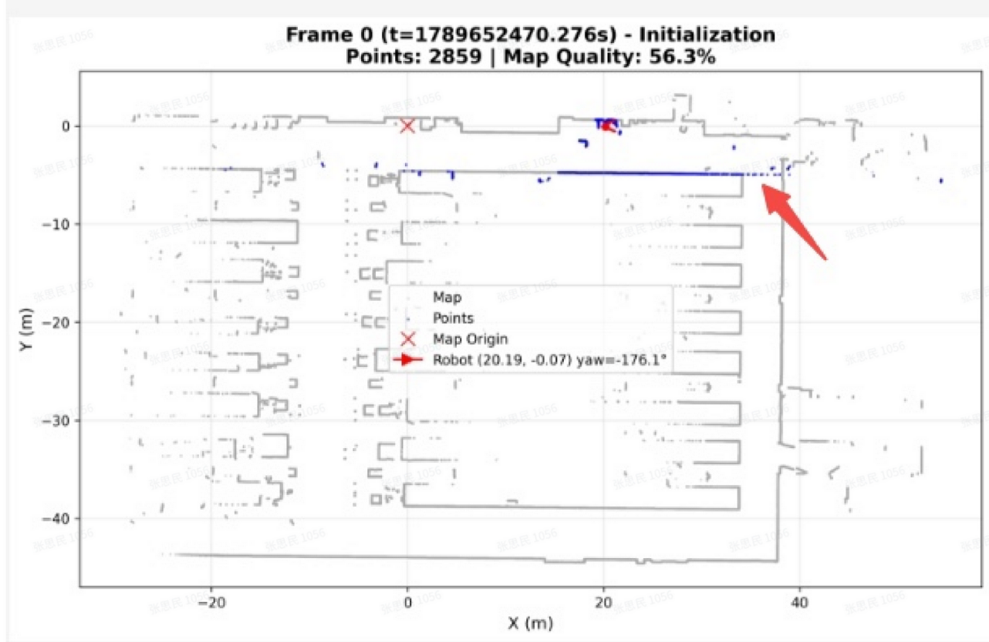
Later, the new localization package can re-localize successfully in the red area, improving the success rate in that area. However, if a task is randomly triggered to start re-localization in similar areas of long corridors and the laser does not hit the front-rear constraint features (blue area), re-localization offset may occur.
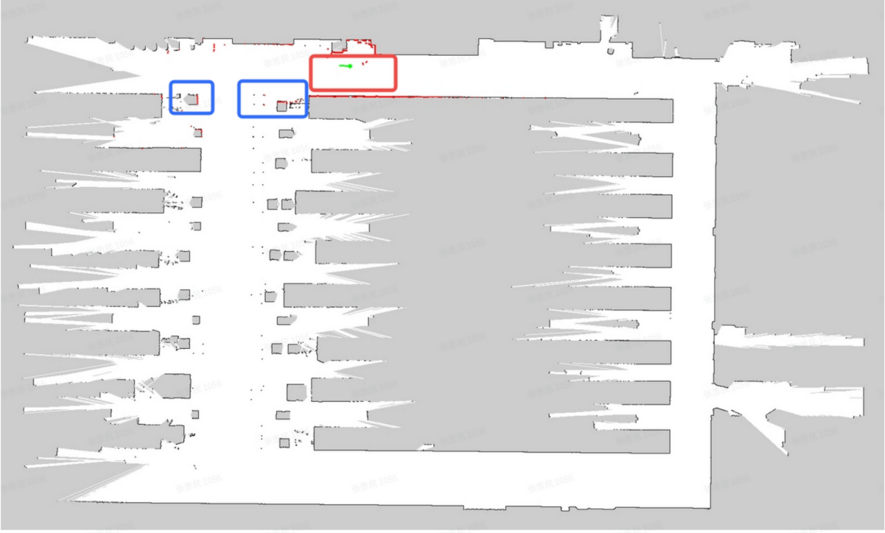
Solution:
The following is the map used by secondary-development customers. This scene has more long corridors and more symmetrical similar areas, so during deployment, pay attention to deploying in the following way, and inform the customer/user of the feasible re-localization areas, which can reduce the risk of re-localization mislocation.
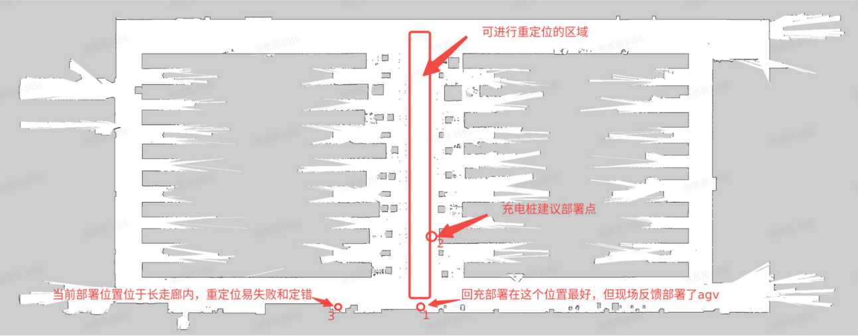
Notes:
Later, the customer needs to delete the previous map file /etc/walker/maps/swd0901/uslam_2d/dynamic_map.db to ensure that the map file previously mis-updated due to mislocalization is cleared.


